Figures
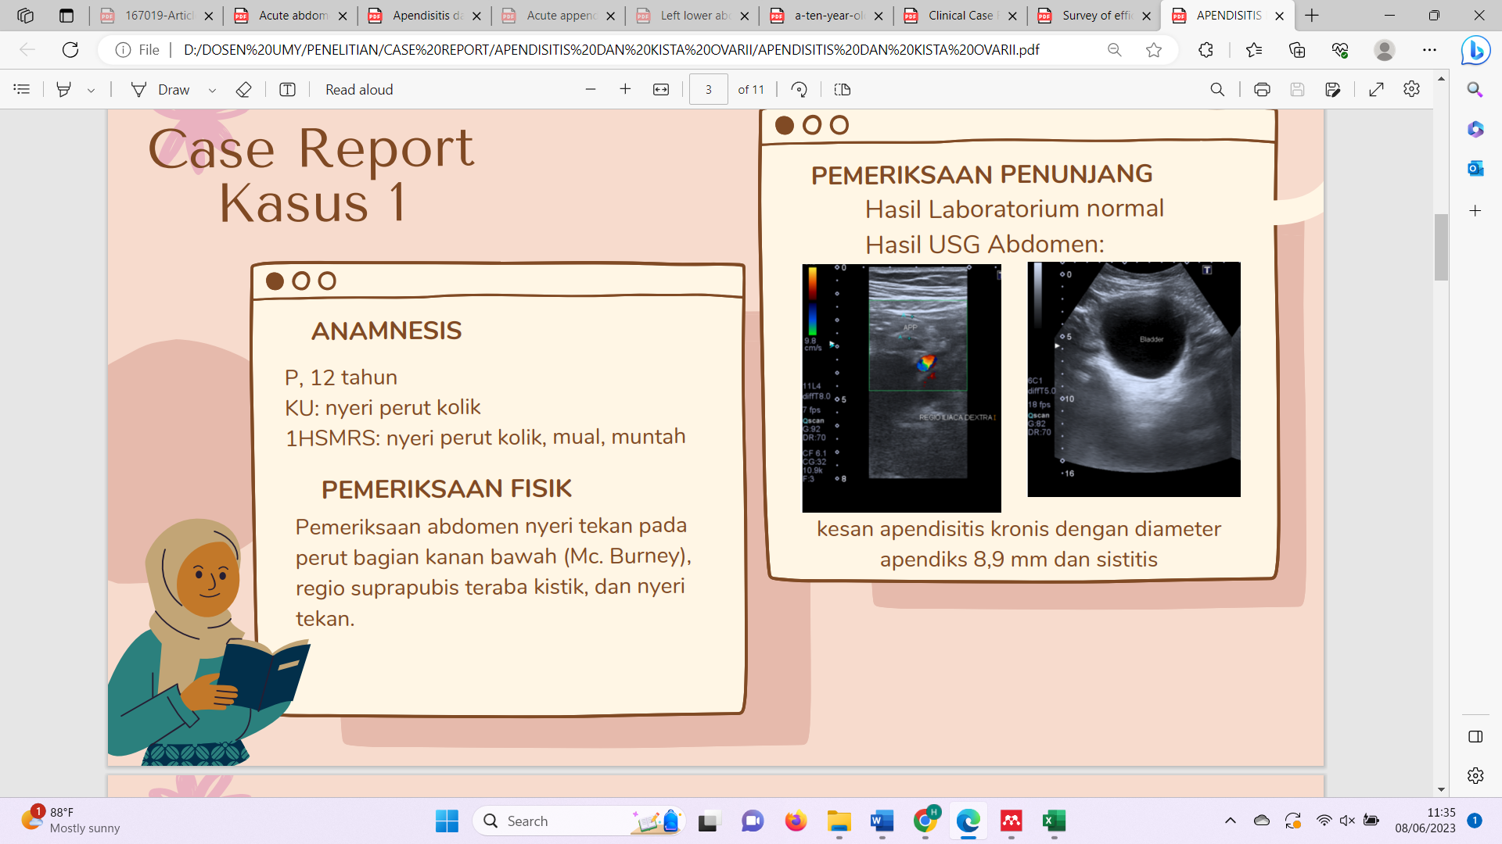

Figure 1. Case 1: Abdominal ultrasound: dilated appendix diameter 8.9 mm

Figure 2. Case 1: Abdominal ultrasound: cystitis

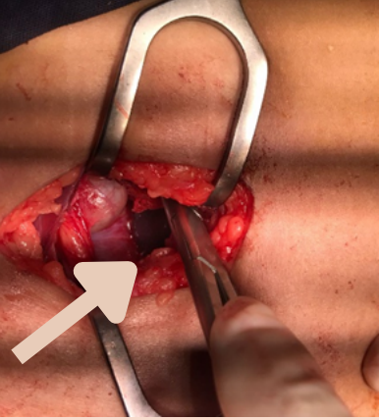
Figure 3. Case 1: A black mass discovered during surgery

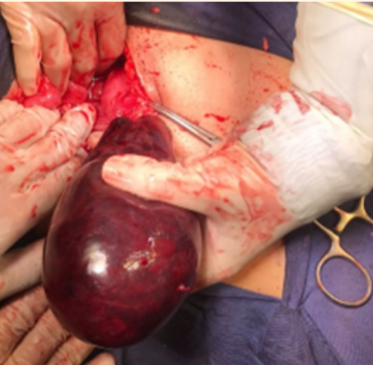
Figure 4. Case 1: Abdominal exploration revealed torsion of the right tube and ovary

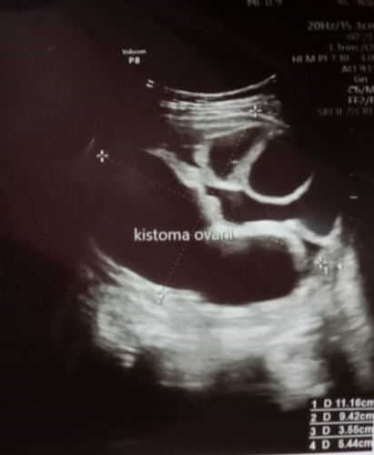
Figure 5. Case 2: Abdominal ultrasound: lobulated cysts in the uterus

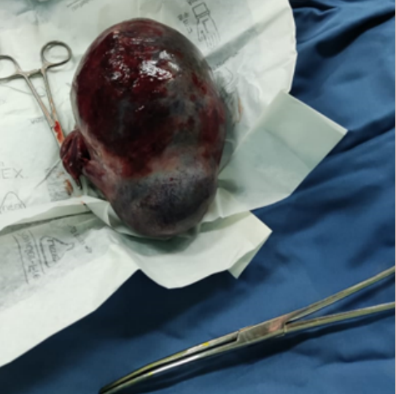
Figure 6. Case 2: torsion of the right tube and ovary

