Sidhi Laksono, et al.

CASE REPORT

CASE SERIES OF LEFT ATRIAL MYXOMA IN ELDERLY AND CHILDREN
Sidhi Laksono^{1,2}*, Ferel Manuputty¹, Hengkie Frankie Lasanudin¹, Ananta Siddhi Prawara³, Steven Philip Surya⁴

¹Department of cardiology and vascular medicine, RS Pusat Pertamina, South Jakarta
²Faculty of medicine, Universitas Muhammadiyah Prof. DR. Hamka, Tangerang
³Faculty of medicine, Universitas Diponegoro, Semarang, Indonesia
⁴Primaya Hospital, Tangerang, Indonesia
*Corresponding author: sidhilaksono@uhamka.ac.id

ABSTRACT
Cardiac myxoma is a rare heart disease. Cardiac myxoma can manifested in both intracardiac and extracardiac. This report aimed to describe the importance of a careful history taking, physical examination, echocardiography, and complete surgical resection for the management of atrial myxoma in two patients with a different group of age and sex. In this case series, we reported two cases: a 64 years old female and a 16 years old male with neurological deficit as the chief complaint. The two patients underwent brain imaging and echocardiography evaluation. Both were diagnosed with left atrial myxoma and brain infarction. Surgical resection of the left atrial myxoma was successfully done in both patients and afterward, both were being monitored in the outpatient clinic.
Keywords: cardiac tumors, transthoracic echocardiography, tumor ressection

ABSTRAK
Miksoma jantung adalah penyakit jantung yang langka. Miksoma jantung dapat bermanifestasi pada intrakardiak dan ekstrakardiak. Tujuan kami melaporkan kasus ini adalah untuk menjelaskan pentingnya anamnesis, pemeriksaan fisik, ekokardiografi, dan reseksi bedah komplit untuk menangani miksoma atrium pada dua pasien dengan kelompok usia dan jenis kelamin yang berbeda. Serial kasus ini melaporkan dua kasus: seorang perempuan 64 tahun dan seorang laki-laki 16 tahun dengan keluhan utama berupa defisit neurologis. Kedua pasien menjalani pencitraan otak dan evaluasi ekokardiografi. Keduanya didiagnosis dengan mikosma atrium kiri dan infark pada otak. Reseksi bedah pada miksoma atrium kiri kedua pasien berjalan lancar dan setelahnya, kedua pasien dimonitor di klinik rawat jalan.
Kata Kunci: ekokardiografi transtorakal, reseksi tumor, tumor jantung

INTRODUCTION
Cardiac myxoma is a rare disease in the cardiovascular world. Most often it was found accidentally during cardiac imaging examination. The epidemiological study showed that the cardiac myxomas incidence was only 0.25% of all heart diseases and the incidence was even smaller in children which were 0.03-0.08%.(Anpalakhan, Ramasamy and Fan, 2014; Boutayeb A, Mahfoudi L, 2017) In another study, it was found that female is more likely to have cardiac myxoma compared to male (70.83% vs 29.17%).(Akhter et al., 2018) Myxoma is a non-cancerous tumor that made up half of the cardiac tumors and around 75% of cardiac myxoma present in the atrium.(Roever et al., 2014) Statistically, myxomas are more frequently found in the left atrium than right atrium and usually, it was found in the 6th decade of life.(Thyagarajan et al., 2017) Left atrial pedunculated myxoma can disturb the function of the valve by swinging into and out of the mitral valve with the blood flow.(Roever et al., 2014) Atrial myxoma can cause sudden complete blockage that damage the valve, promote pulmonary congestion, and might end up causing stroke. A careful approach needs to be done in diagnosing atrial myxoma because it could be misled with other heart diseases that occur more commonly.(Roever et al., 2014; Thyagarajan et al., 2017) Despite its rarity, we are reporting two patients: 64 years old female and 16 years old male with atrial myxoma that came to our hospital.

CASE 1
A 64 years old female came with chief complaint weakness on right extremities starting from three days ago. There was a history of CVD and HNP in 2015. She looked ill with GCS E4VxM6. Her vital sign was normal and from the physical examination, we found aphasia, asymmetric face (NVII paralysis), diastolic murmur grade 3/6 and early diastolic plop during cardiac auscultation, and the motoric strength was 1 point for her right extremities. Serial laboratory tests showed normal cardiac enzyme in two measurement of high sensitive cardiac troponin test (hs-cTnT) 10,57 ng/L and 13,01 ng/L. The patient had high lipid profile: total cholesterol 444 mg/dL, triglyceride 165 mg/dL, and LDL 371 mg/dL. Brain MRI showed acute ischemic infarct on the left temporal-parietal lobe. The ECG showed sinus rhythm (SR) with left ventricular hypertrophy and the chest X-Ray showed cardiomegaly. The echocardiography showed left atrial dilatation with severe mitral regurgitation, a large mass in the left atrium that attached to mid interatrial septum, moving in and out through mitral valve (MV), and the left ventricular ejection fraction (LVEF) was 73% (figure 1). A diagnosis of left atrial myxoma and acute ischemic infarct on the left temporal-parietal lobe was made, and the patient was planned to undergo coronary angiography to evaluate the coronary arteries for the preparation of left atrial myxoma resection. The coronary angiography showed 99% stenosis on the right coronary artery (RCA) dan 74% stenosis on the left circumflex artery (LCX). Referring to the findings, the patient was planned to undergo coronary artery bypass graft (CABG) and resection of left atrial myxoma. Two grafts were successfully planted to bypass the stenosis on the RCA and LCX. Afterward, the resection of 8 cm x 5 cm x 4 cm left atrial myxoma was completed. Post-operation echocardiography showed normal left atrium (LA) dan left ventricle (LV), LVEF remained 73%, and no intracardiac mass. The histopathology findings from the left atrial myxoma showed polypoid form and hypocellular accompanied by small capillary covered by endothelial with stroma fibrosis (figure 2). The case was concluded to be left atrial myxoma with focal fibrosis. The patient had several physiotherapies for her weakness in the right extremities. For the pharmacologic treatment, the patient was prescribed anticoagulant and was being monitored in the outpatient clinic.
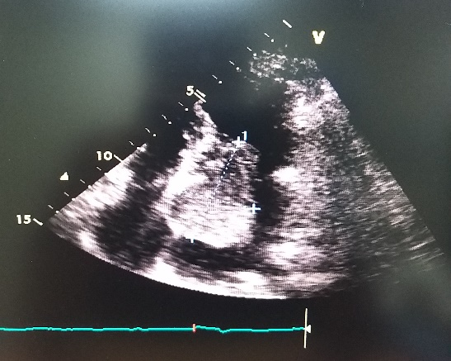
Figure 1. Echocardiography of case 1 showed atrial myxoma on left atrium

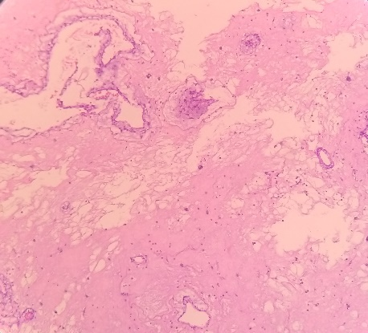
Figure 2. Atrial myxoma histopathology showed polypoid form with focal fibrosis

CASE 2
A 16 years old male came with chief complaint loss of consciousness for almost one hour and weakness on the right extremities starting from a day before. There was no history of any disease. He looked ill with GCS E4V5M6. His vital sign was normal and from the physical examination, we found dysarthria, asymmetric face (NVII Paralysis), diastolic murmur grade 2/6 during cardiac auscultation, and the motoric strength was 2 points for the right extremities. Laboratory tests showed no abnormality. ECG showed SR with a normal axis and chest x-ray showed no abnormality. Brain CT scan showed multiple hyperacute lacunar infarcts on the left cerebellum (figure 3). MRA brain showed occlusion on the left medial cerebral artery, acute infarct on the left parietal lobe with extension to the frontal and temporal lobe (figure 4). CTA coronary showed an interatrial solid lesion with contrast filling defect. The echocardiography showed a large mass attached to anterior mitral leaflet (AML) with a size of 2,8 cm x 5,1 cm moving in and out through MV (figure 5). A diagnosis of left atrial myxoma, occlusion on the left medial cerebral artery, and acute infarct on the left parietal lobe with extension to the frontal and temporal lobe was made. The patient underwent resection of the left atrial myxoma. Post-operation echocardiography showed normal LA dan LV, no intracardiac mass with LVEF 58%. The histopathology findings from the atrial myxoma showed the tissues consist of myxomatous matrix mass and the extracellular tissues consist of vascular myxomatous. The case was concluded to be left atrial myxoma. The patient had several speech therapies for dysarthria and physiotherapy for his weakness on the right extremities. For the pharmacologic treatment, the patient was prescribed anticoagulant and was being monitored in the outpatient clinic.
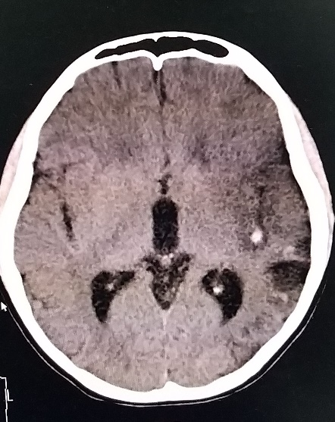
Figure 3. CT scan of case 2 showed multiple hyperacute lacunar infarct on the left cerebellum
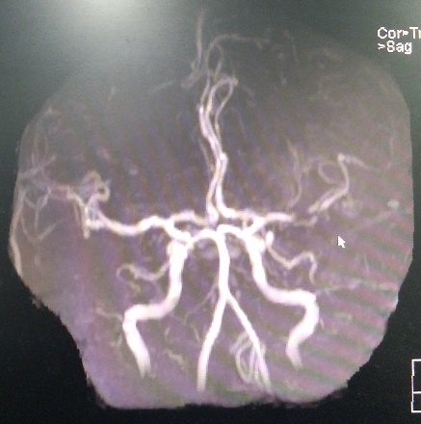
Figure 4. MRA brain of case 2 showed occlusion on middle cerebral artery
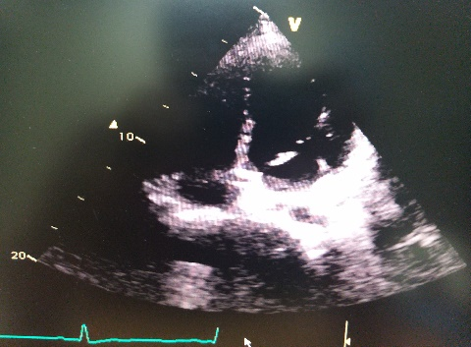
Figure 5. Echocardiography of case 2 showed left atrial myxoma

DISCUSSIONS
Diagnosing atrial myxomas might be tricky and could be misled with mitral valve disease, tricuspid valve disease, ischemic heart disease, or cardiomyopathy which could be found more often in daily practices.(Roever et al., 2014; Thyagarajan et al., 2017) The classic triad of cardiac myxoma is 1) symptoms due to cardiac obstruction 2) symptoms due to cerebral or peripheral embolism 3) constitutional symptoms like fever and fatigue.(Yuan, Yan and Wu, 2017) Most of the patients came to the hospital with symptoms due to intracardial obstruction or central or peripheral embolism. (Ekström and Svenarud, 2015) Systemic embolization occurred on one-third of cardiac myxoma patients.(Novak et al., 2017) The incidence of coronary embolization is 0.06%. The low rate of coronary embolization is due to two reasons which are; the coronary Ostia are perpendicular to the aortic blood flow and the opening of aortic valve leaflet protect coronary Ostia during cardiac systole.(Arcenas and Ali, 2013)
In this case series, both patients came to the hospital with neurological deficits and during cardiac auscultation, diastolic murmur was heard in both patients. These suggest that the neurological deficit might be the result of the heart problem, in this case, atrial myxoma. Left atrial pedunculated myxomas can swing freely with the blood flow into and out of the mitral valve especially with gravity force, and it could disrupt the function of the valve. When the myxoma blocks the function of the valve, the blood flow will stop immediately and it may cause pulmonary congestion. The mitral valve might be damaged and black flow might occur resulting in a cardiac murmur.(Roever et al., 2014) However, either blood clots from the myxoma surface or a piece of fragmented of the myxomas might detach and cause obstruction in the blood vessel. The obstruction might end up causing stroke in the cerebral blood vessel and other symptoms based on the location. (Thyagarajan et al., 2017)
Transthoracic echocardiography has up to 95% sensitivity on diagnosing atrial myxoma. There are two different anatomic appearances of atrial myxomas according to echocardiography findings. The first appearance is solid and round with a non-mobile surface, while the second appearance is polypoid, soft, and irregular shape and friable surface.(Cacciapuoti et al., 2016) The latter is associated with a higher incidence of embolization until up to 58%.(Boutayeb A, Mahfoudi L, 2017) Cardiac myxoma is more common to be found in the left atrium than other chambers of the heart and attached on the fossa ovalis region of the septum.(Gupta et al., 2019) In addition to echocardiography, histopathological analysis is required to differentiate cardiac myxoma from its differential diagnosis which are intracardiac thrombus, papillary fibroelastoma, lipoma, and rhabdomyoma.(Ziccardi, Tariq and Limaiem, 2020) Cardiac myxoma may be related to Carney syndrome. Besides cardiac myxoma, the development of endocrine and thyroid tumors is more likely to occur in patients with Carney syndrome. Carney syndrome is an autosomal dominant condition. Molecular genetic studies showed that mutation on PRKAR1A gene encoding the R1a regulatory subunit of cyclic-AMP-dependent protein kinase A (PKA) causes inherited myxoma in the setting of the Carney complex tumor syndrome.(Stratakis and Raygada, 2018) However, in both cases, we didn’t examine the genetic studies.
Urgent surgical resection of atrial myxoma is recommended to be done urgently due to the risk of embolization. The long term prognosis of the patients is very good, cardiac myxoma mostly occurs sporadically, and surgery is curative with recurrence rate 1-3%.(Khan et al., 2013) Cardiac recurrence may be secondary to incomplete resection of the tumors, implantation of the tumor cells during excision, or the new growth of pretumor or reserve cell. These recurrences may be more infiltrative than original tumors. Failure of constitutional symptom to resolve, elevated gamma globulin, and increased erythrocyte sedimentation rates after successful resection may indicate residual extracardiac tumors and may serve as means identifying the malignant cardiac myxomas.(Seethala, 2013)

CONCLUSIONS
In conclusion, most common primary cardiac tumors are atrial myxomas. Signs and symptoms may vary between patients with atrial myxoma. Stroke is one of the extracardiac manifestations of atrial myxoma. Thus, it is crucial to evaluate the presence of atrial myxoma in stroke patients. The use of TTE is important in diagnosing atrial myxoma. Resection of atrial myxomas is curative with excellent long-term prognosis and low chance of recurrences.

ACKNOWLEDGMENT

The authors thank all who support this case report.

REFERENCES
Akhter, A. et al. (2018) ‘Cardiac Myxomas: A Histodemographic Analysis’, Delta Medical College Journal, 6(1), pp. 4–8.
Anpalakhan, S., Ramasamy, D. and Fan, K. S. (2014) ‘An unusual presentation of atrial myxoma’, Singapore Medical Journal, 55(10), pp. e156–e158.
Arcenas, R. F. and Ali, M. I. (2013) ‘Left Atrial Myxoma: A Rare Nonatherosclerotic Cause of Acute Myocardial Infarction’, Case Reports in Cardiology, 2013(Figure 2), pp. 1–4.
Boutayeb A, Mahfoudi L, M. S. (2017) ‘Atrial Myxoma: From Diagnosis to Management’, Clinics in Surgery, 2, p. 1498.
Cacciapuoti, Fulvio et al. (2016) ‘Two-dimensional speckle tracking echocardiography and three-dimensional echocardiography characterization of left atrial giant myxoma’, Journal of Cardiovascular Echography, 26(2), pp. 68–70.
Ekström, M. and Svenarud, P. (2015) ‘Atrial myxoma: A rare but well-described cause of increased erythrocyte sedimentation rate and anaemia’, BMJ Case Reports, 2015, pp. 1–4.
Gupta, S. et al. (2019) ‘Left Atrial Myxoma Presenting as Lateral Medullary (Wallenberg’s) Syndrome’, Case Reports in Cardiology, 2019(6), pp. 1–4.
Khan, M. et al. (2013) ‘Cardiac myxoma: A surgical experience of 38 patients over 9 years, at SSKM hospital Kolkata, India’, South Asian Journal of Cancer, 2(2), p. 83.
Novak, M. et al. (2017) ‘The First Manifestation of a Left Atrial Myxoma as a Consequence of Multiple Left Coronary Artery Embolisms’, The Journal of Critical Care Medicine, 3(3), pp. 111–117..
Roever, L. et al. (2014) ‘Cardiac tumors: A brief commentary’, Frontiers in Public Health, 2(DEC), pp. 2–4.
Seethala, S. (2013) ‘Left ventricular myxoma: Missed vs metastatic’, World Journal of Cardiology, 5(10), p. 387.
Stratakis, C. and Raygada, M. (2018) Carney Complex. Edited by M. Adam, H. Ardinger, and R. Pagon. Seattle (WA): GeneReviews.
Thyagarajan, B. et al. (2017) ‘Extracardiac manifestations of atrial myxomas’, Journal of the Saudi Heart Association. King Saud University, 29(1), pp. 37–43.
Yuan, S. M., Yan, S. L. and Wu, N. (2017) ‘Unusual aspects of cardiac myxoma’, Anatolian Journal of Cardiology, 17(3), pp. 241–247.
Ziccardi, M. R., Tariq, M. A. and Limaiem, F. (2020) Cancer, Cardiac. Treasure Island (FL): StatPearls Publishing LLC.

