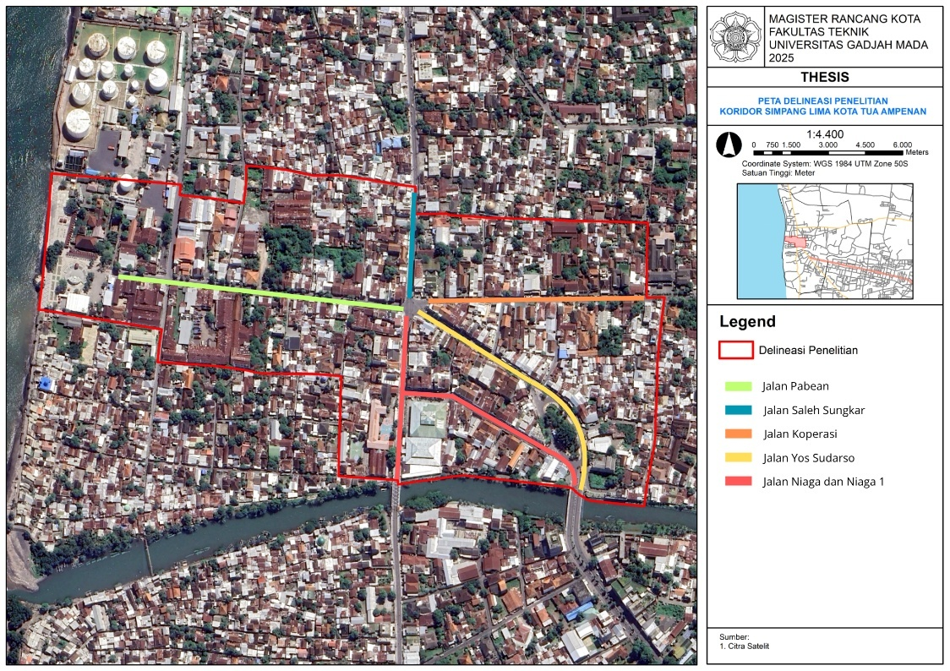

Figure 1. Map Delineation of the Simpang Lima Corridor

Source: Research Results, 2025

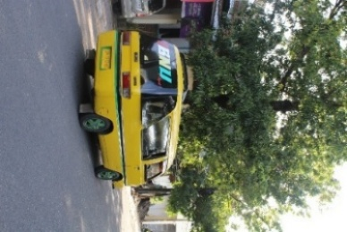 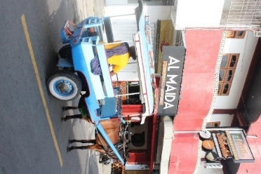

Figure 2. Types of Public Transportation in the Simpang Lima Corridor

Source: Research Results, 2025

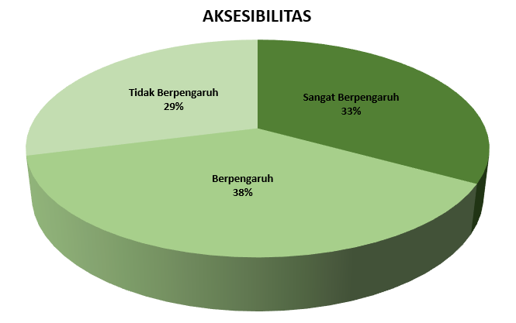

Figure 3. Percentage of Accessibility Factors

Source: Research Results, 2025

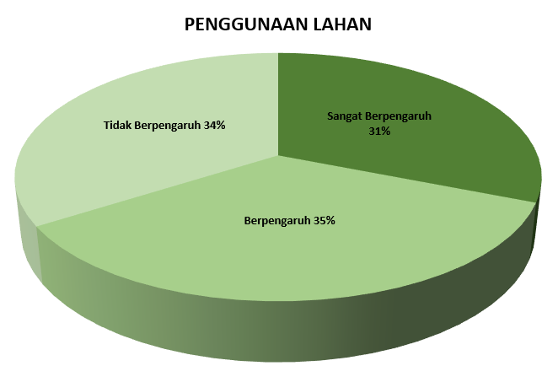

Figure 4. Percentage of Land Use Factors

Source: Research Results, 2025

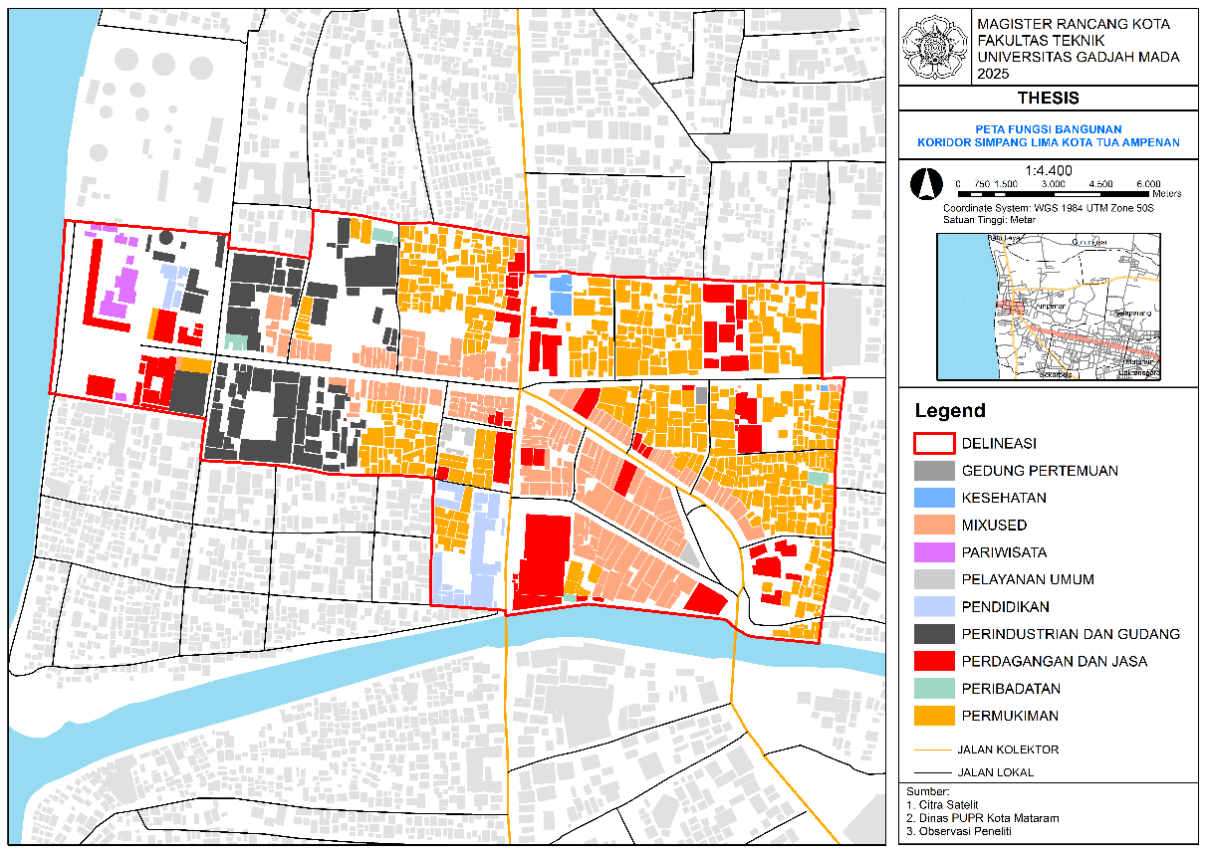

Figure 5. Distribution of building functions

Source: Research Results, 2025

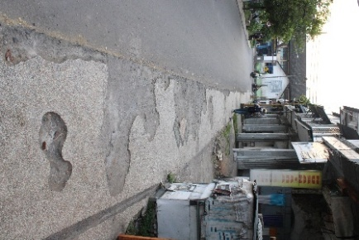 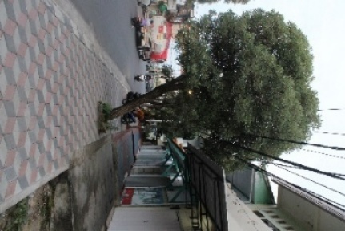 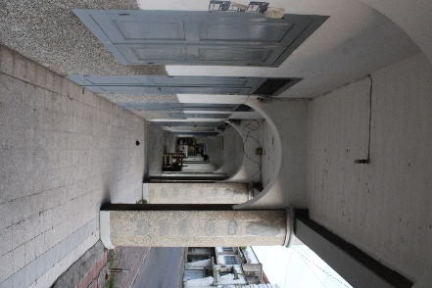

Figure 6. Pedestrian Way Conditions

Source: Research Results, 2025

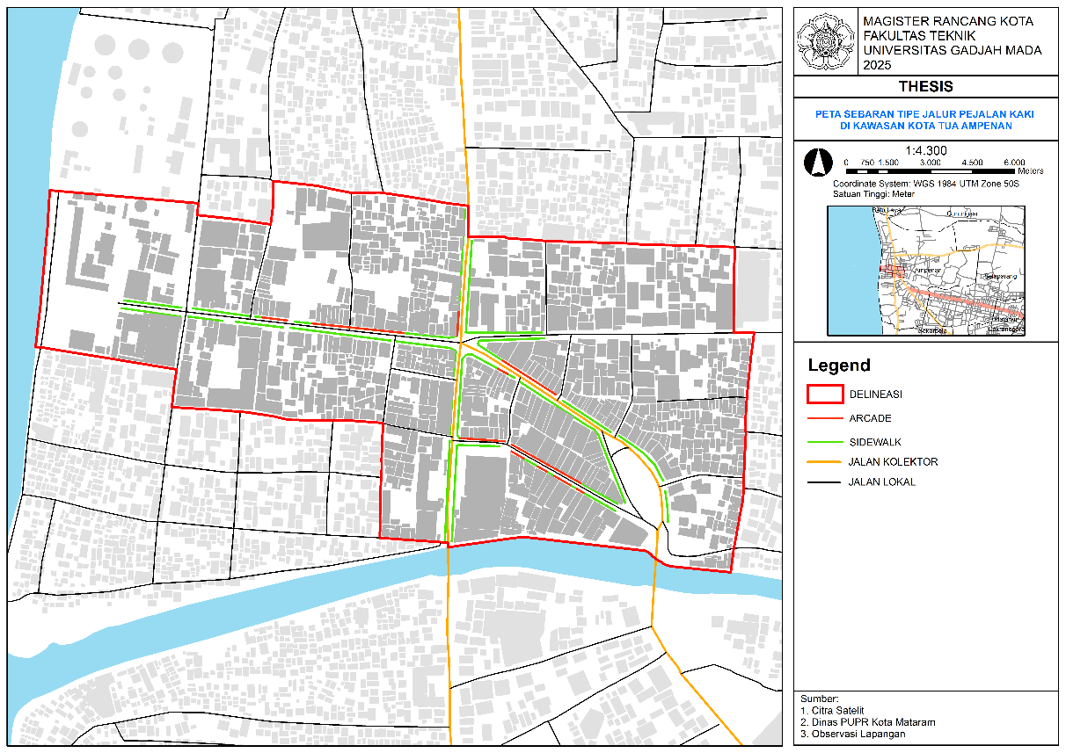

Figure 7. Distribution of Pedestrian Way Typology

Source: Research Results, 2025

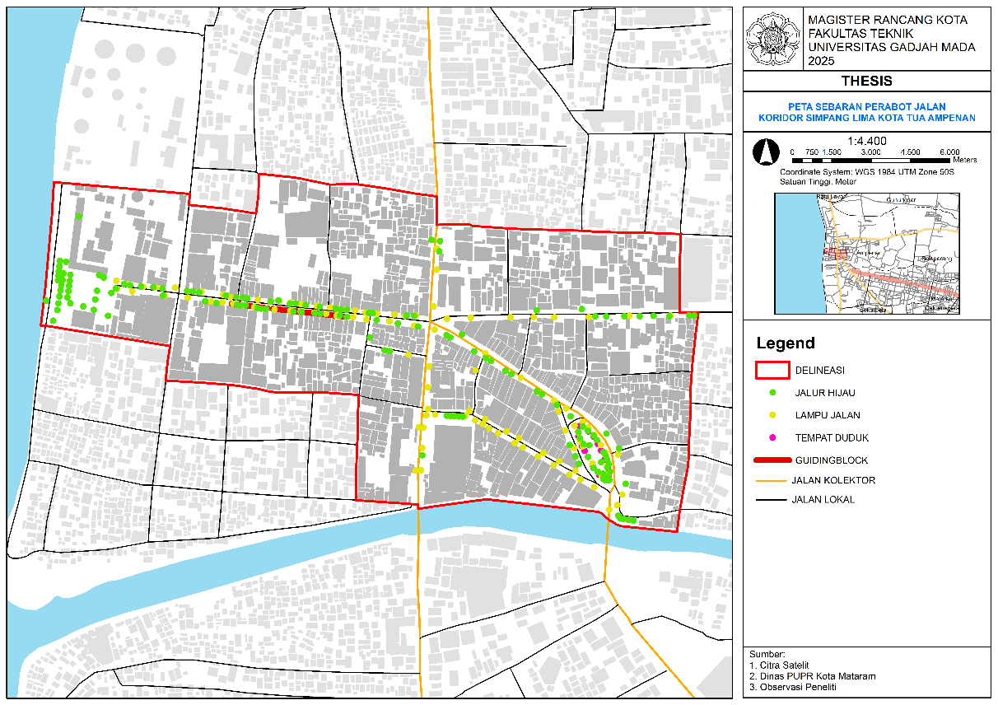

Figure 8. Distribution of Street Furniture

Source: Research Results, 2025

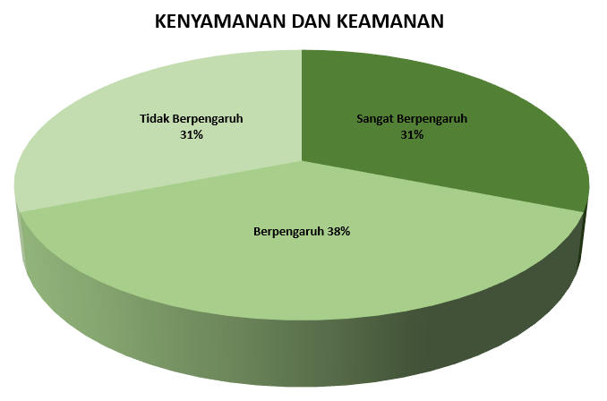

Figure 9. Percentage of Comfort and Safety Factors

Source: Research Results, 2025

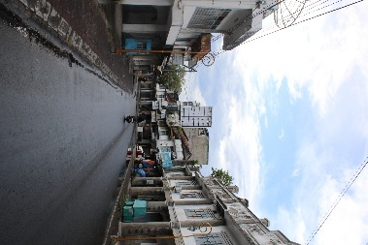 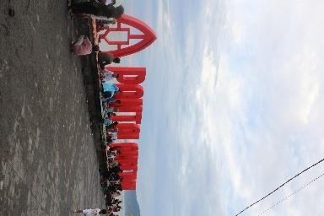 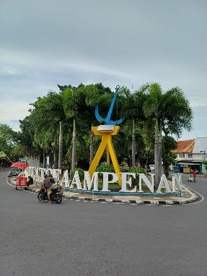

Figure 10. Attraction of the Simpang Lima Corridor

Source: Research Results, 2025

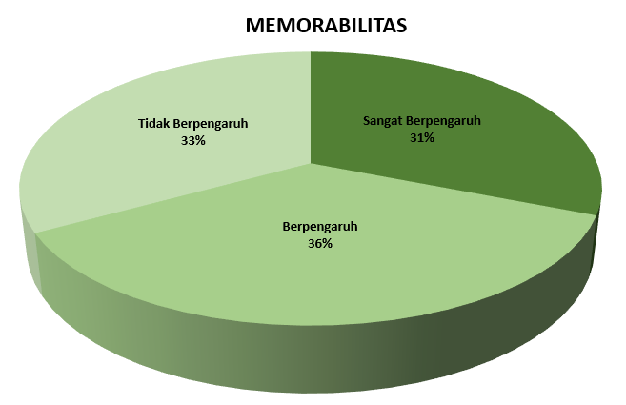

Figure 11. Percentage of Memorability Factors

Source: Research Results, 2025