**Housing Needs Assessment in Parakan Urban Area of Temanggung Regency**

**Khristiana Dwi Astuti1*, Reny Yesiana1,   
Hendy Wahyu Noerhidayat2, Nefia Nur Fitri1,   
Delia Puspita1**

1 Spatial Planning and Land Management, Department of Civil and Planning, Vocational School, Diponegoro University, Indonesia

2 Public Works and Spatial Planning Office Temanggung Regency    
* Email Korespondensi : khristiana.dwiastuti@live.undip.ac.id

***ABSTRAK***

*Urban areas are very fast growing because they are the center of community activities with adequate infrastructure and facilities for the needs of people's lives so that they affect land availability (Bai et al., 2021). Parakan District is a sub-district in Temanggung Regency which has been designated as the Parakan Urban Area based on the Regional Regulation of Temanggung Regency Number 1 of 2024, urban areas with good development can cause urbanization and spatial density. Therefore, it is necessary to identify housing needs and the availability of land that can be developed into housing. The research method used in this study is quantitative. This research includes population analysis using the geometric method, backlog of housing needs using variables of the projected number of families and the number of existing houses, housing and land needs based on the class of houses from the reference of Government Regulation Number 12 of 2021 and land availability using the overlay method. The final results showed that the population increased in 2043 so that the total area of land needed for settlements was 35.13 ha. The availability of land that can be developed until 2043 it is 243.97 ha..*

*Kata Kunci:* Housing Needs, Land Availability*, Parakan*

**ABSTRAK**

Kawasan perkotaan sangat cepat berkembang dikarenakan menjadi pusat aktivitas masyarakat dengan infrastruktur dan fasilitas yang memadai untuk kebutuhan hidup masyarakat sehingga berpengaruh terhadap ketersediaan lahan (Bai et al., 2021). Kecamatan Parakan merupakan kecamatan yang terdapat di Kabupaten Temanggung yang sudah ditetapkan sebagai Kawasan Perkotaan Parakan berdasarkan Peraturan Daerah Kabupaten Temanggung Nomor 1 Tahun 2024, wilayah perkotaan dengan pembangunan yang baik dapat menimbulkan urbanisasi dan kepadatan ruang. Oleh karena itu, perlu dilakukannya identifikasi kebutuhan rumah dan ketersediaan lahan yang dapat dikembangkan menjadi perumahan. Metode penelitian yang digunakan dalam penelitian ini adalah kuantitatif. Penelitian ini meliputi analisis kependudukan metode geometrik, backlog kebutuhan rumah menggunakan variabel jumlah proyeksi KK dan jumlah rumah eksisting, kebutuhan rumah dan lahan berdasarkan kelas rumah dari acuan Peraturan Pemerintah Nomor 12 Tahun 2021 serta ketersediaan lahan dengan metode overlay. Hasil akhir penelitiaan menunjukkan jumlah penduduk meningkat pada tahun 2043 sehingga luas total kebutuhan lahan bagi permukiman seluas 35,13 ha. Dengan ketersediaan lahan yang dapat dikembangkan hingga tahun 2043 yaitu seluas 243,97 ha.

Kata Kunci: Kebutuhan Rumah, Ketersediaan Lahan, Parakan

# INTRODUCTION

The development of housing and residential areas has an important role in the development and development of human resources (Zhu et al., 2023). Based on Law No. 1/2011 on housing and residential areas, a house is a building that serves as a place of residence or shelter for humans, as well as a means to foster family life. Based on its function, a house is a shelter that provides proper protection, access to resources, and a sense of security for its occupants. (Rahman, 2010). Fulfillment of housing will continue to grow as an individual or family need along with the development of the area and its population (Li et al., 2018).

Land availability is also an important factor when the population continues to grow, because the higher the need and demand for housing, the need for land for housing development is also increasing (Rumondor et al., 2024). The development of housing and settlements, especially in urban areas, occurs due to the development of community activities that can attract migrants from rural areas, known as urbanization (Firdianti, 2010). The motivating factors for moving to urban areas are adequate health facilities, high standard of living, high standard of education, recreational facilities, better job opportunities, better security of life and property ownership, and a more conducive social environment (Widiawaty, 2023).

Parakan Urban Area located in Parakan District of Temanggung Regency in 2020 has a population of 53,322 people, or about 7% of the total population of Temanggung Regency. Based on Regional Regulation Number 1 of 2024 concerning the Regional Spatial Plan of Temanggung Regency for 2024-2044, the Parakan Urban Area is one of the Local Activity Center (PKL) areas to serve district-scale activities or several sub-districts. In the economic sector, the Parakan Urban Area is the center of economic activity marked by the presence of Pasar Legi, which is the main market that has existed since 1925 with a range of service areas covering Temanggung Regency to Wonosobo Regency. Health facilities in the Parakan Urban Area are Ngesti Waluyo Hospital in Wanutengah Village and Muhammadiyah Hospital in Campursari Village which are able to support the health needs of the Parakan Urban Area community and the surrounding area. In the aspect of education, the Parakan Urban Area has STIKES Ngesti Waluyo as a means of supporting education that serves one Temanggung Regency. As well as the existence of national roads that can increase the possibility of interaction between the activities of the population of the Parakan Urban Area with Temanggung Regency and the surrounding districts.

Limitations in meeting housing needs by looking at the availability of land and the number of residents who are increasing every year in the Parakan Urban Area, so it is important to calculate the backlog of housing needs, housing and land needs based on the class of houses (Novitawaty, 2017). The calculation of housing needs (backlog) for the Parakan Urban Area in this study uses variables of the number of projected families and the number of existing houses which aims to determine housing and land needs based on the class of urban housing. Several studies with similar themes have been conducted, including research that calculates housing needs using variables of the number of projected families and the number of houses in Pesisir Barat Regency in 2018-2037 (Fahmi; & Widyawati, 2020). In addition, the calculation of housing and settlement area development needs considers the variable number of projected families, the number of houses and then calculates the need for new houses based on the class of houses and land for public infrastructure and facilities in Tanggamus Regency in 2022-2041 (Fasola et al., 2022). The difference between the study of research housing needs in the Parakan Urban Area with the results of several other studies is the spatial analysis of land availability with the overlay method that can be developed for housing development in the Parakan Urban Area of Temanggung Regency.

The existence of various activity centers and economic potential in the Parakan Urban Area makes people come and immigrate to the Parakan Urban Area. This has an impact on the increasing need for housing land to live in. Based on the description above, the purpose of this study is to determine the need for housing in the planning year and the availability of land that can be developed for housing in the Parakan Urban Area of Temanggung Regency.

# METHODS

The focus of this research is the Parakan Urban Area with an area of 1,433.93 hectares or 1.65% of the total area of Temanggung Regency. The Parakan Urban Area is divided into 2 (two) urban villages and 11 (eleven) villages. Parakan Urban Area is located in the geographical position of 7.2508°- 7.3016° N and 110.0901°- 110.0731° East. Administratively, this urban area is bounded by:

* North : Ngadirejo District, Sebagian Parakan District (Bagusan Village)
* East : Kedu District, Sebagian Parakan District (Nglondong Village)
* South : Sebagian Bulu District (Gandurejo Village, Tegalrejo Village, Tegalurung Village) dan Sebagaian Parakan District (Sunggingsari Village, Glapansari Village); dan
* West : Bansari District dan Kledung District

The research method used in the study of housing needs in the Parakan Urban Area uses a quantitative approach (Musianto, 2002). This approach is to perform calculations, formulas and numerical certainty using secondary data obtained from the data of the Central Bureau of Statistics of Parakan Subdistrict in figures for 2010-2022 in the form of population data and primary data, namely the number of house points. Meanwhile, the spatial data used are shapefile maps of built-up land (roads and settlements), conservation land (LSD, spring boundaries, and river boundaries), and green open spaces (parks, cemeteries, and fields) which are processed using a geographic information system, namely Arcgis (Roziqin & Kusumawati, 2017).

1. Population Projection

Population projection is the calculation of the estimated population in the future (Chen et al., 2016). The method used to calculate the population growth rate is:

r = $\frac{(current population -population last year)}{population last year}$ × 100%

Calculation of population projections using the geometric method by assuming that the population will increase geometrically based on the calculation of compound interest (Handiyatmo et al., 2010).

**Geometric Method**

Pn= ${(Po×(1+r)}^{n}$…………………………………………………….… (2.1)

Description :

Pn = Total population in year n

Po = Total population in the initial year of planning

n = Planning time period (Year)

r = Population growth rate

1. Projected Number of Family Heads

Determination of the number of houses, requires data on the number of residents in the projection year and assumes that 1 housing unit per 1 KK (Family Card) of 4 people (Badan Standardisasi Nasional, 2004).

Number of households Projection Year = $\frac{Populations projections (2.1)}{4}$……..(2.4)

1. Backlog Analysis of Housing Needs

The calculation of the housing backlog is used to identify housing needs, so that it can be known that there is no availability of houses or a shortage of houses (backlog). (Marjorie Tindas et al., 2023). The following is the housing backlog calculation formula:

Kro = Io (2.4) – Ro………………………………………………………(2.5)

Description :

Kro = Housing shortage or lack of housing availability (Backlog)

Io = Number of families in the year of count

Ro = Number of houses in the year of count

1. Analysis of House Needs Based on House Class

The calculation of housing needs based on the classification of housing classes is obtained from Law Number 1 Year 2011 concerning Housing and Settlement Areas which classifies houses in settlements into three (3) types, namely luxury houses, medium houses, and simple houses.

New House Land Requirement = (Kro (2.5) × 70 $m^{2}$) + (Kro (2.5) × 120 $m^{2}$) + (Kro (2.5) × 200 $m^{2}$) ………………………………………………………(2.6)

Description :

Kro = Housing shortage or lack of housing availability (Backlog)

Luxury Home = 200 $m^{2}$

Intermediate House = 120 $m^{2}$

Simple House = 70 $m^{2}$

1. Land Availability Analysis

The analysis method used is spatial analysis by overlaying each SHP data. Overlay is done to unite/combine information from several different layers/maps to get new, more complex information (Roziqin & Kusumawati, 2017). The data processing process using Arcgis 10.8 is as follows.

1. Prepare the entire SHP of materials that include built-up land (roads and settlements), conservation land (LSD, spring boundaries, and river boundaries), and green open spaces (parks, cemeteries, and fields) and the SHP of Parakan Urban Area.
2. b) Ensure that all SHP materials have been annotated with “not expandable”
3. Open Arctoolbox, then to Analysis Tools select overlay, after that do overlapping (overlay) SHP material with SHP Parakan Urban Area.
4. The overlay results will show there are two classifications of land availability, namely :

* cannot be developed, which are built-up land, Protected/Conservation Land, and Green Spaces
* can be developed, which are areas that do not include built-up land, Protected/Conservation Land, and Green Spaces

1. Land availability is land that can be developed, because there are no restrictions on the development of the land

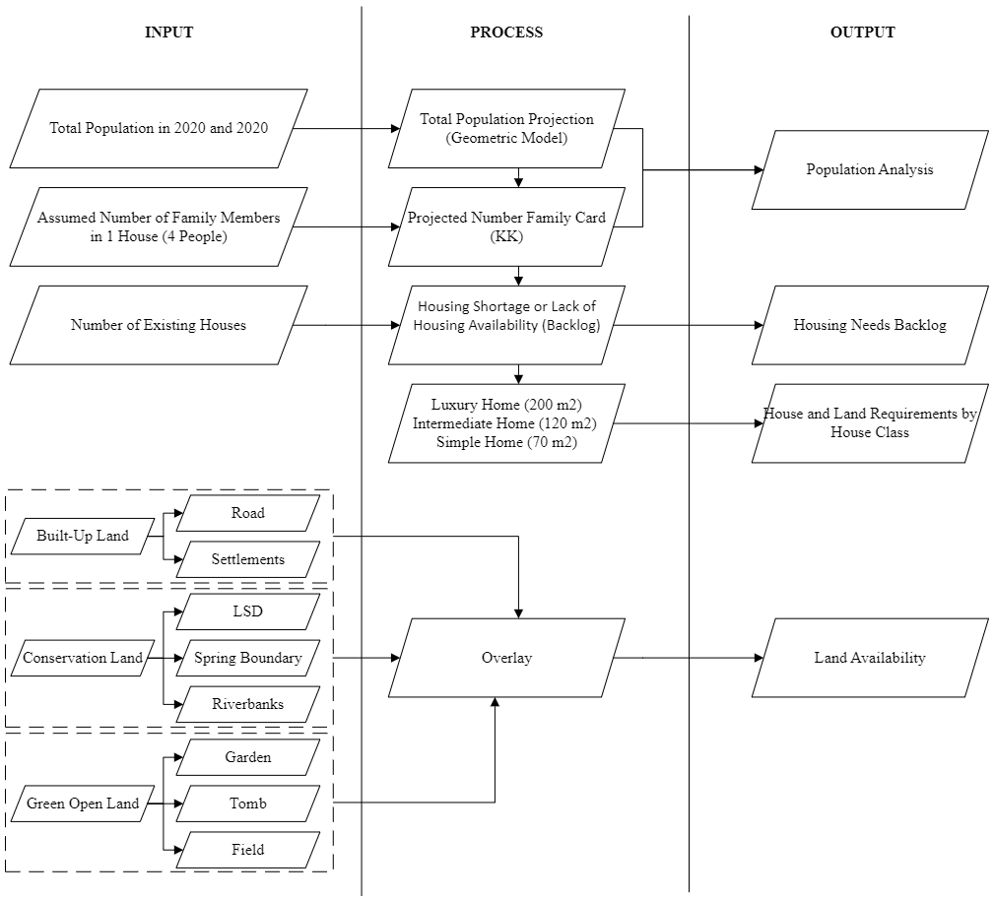

**Figure 1.** Stages of Home Needs Assessment

*Source : 2024 Compiler*

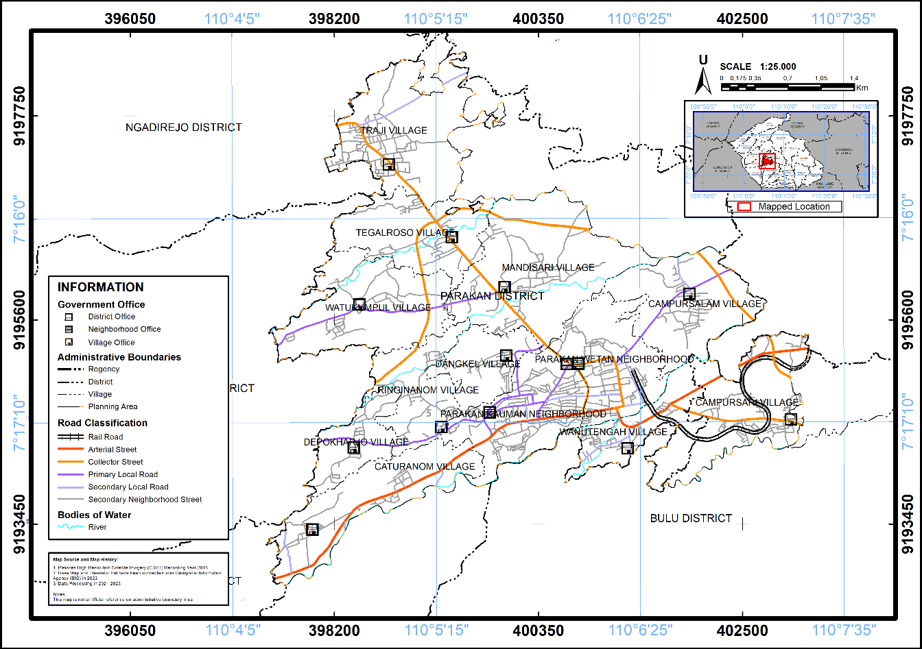

**Figure 2.** Administrative Map of Parakan Urban Area

*Source : 2024 Compiler*

# RESULTS AND DISCUSSION

## Populations

Population projections are used to estimate the future population of an area by considering the projection results that are closest to the actual conditions in the field and choosing the correlation factor that is closest to 1 (Talanipa et al., 2022). The population projection data will then be divided by the average number of household members in the Parakan Urban Area. The average number of household members is assumed to be 4 family members per family card, this figure is quite stable and represents the general condition in Indonesia (Nasution, 2017). The following is the calculation of population projections in the Parakan Urban Area.

**Table 1.** Number of Parakan Urban Area Projections for 2028-2043

|  |  |  |  |  |  |  |  |  |
| --- | --- | --- | --- | --- | --- | --- | --- | --- |
| **Village/ Neighborhood** | **Projected Population (Population)** | | | | **Number of Projected Households** | | | |
| **2028** | **2033** | **2038** | **2043** | **2028** | **2033** | **2038** | **2043** |
| Parakan Kauman Neighborhood | 12.166 | 12.500 | 12.844 | 13.197 | 3.041 | 3.125 | 3.211 | 3.299 |
| Parakan Wetan Neighborhood | 7.009 | 7.070 | 7.130 | 7.192 | 1.752 | 1.767 | 1.783 | 1.798 |
| Traji Village | 3.955 | 4.129 | 4.311 | 4.501 | 989 | 1.032 | 1.078 | 1.125 |
| Wanutengah Village | 4.328 | 4.856 | 5.448 | 6.112 | 1.082 | 1.214 | 1.362 | 1.528 |
| Caturanom Village | 2.786 | 2.983 | 3.195 | 3.421 | 697 | 746 | 799 | 855 |
| Mandisari Village | 5.836 | 6.288 | 6.774 | 7.298 | 1.459 | 1.572 | 1.693 | 1.824 |
| Campursari Village | 2.659 | 2.678 | 4.703 | 2.716 | 665 | 670 | 1.176 | 679 |
| Tegalroso Village | 2.525 | 2.748 | 2.990 | 3.253 | 631 | 687 | 747 | 813 |
| Depokharjo Village | 925 | 978 | 1.034 | 1.094 | 231 | 244 | 259 | 273 |
| Dangkel Village | 2.999 | 3.158 | 3.325 | 3.502 | 750 | 789 | 831 | 875 |
| Campursalam Village | 4.074 | 4.378 | 4.703 | 5.054 | 1.019 | 1.094 | 1.176 | 1.263 |
| Ringinanom Village | 2.337 | 2.453 | 2.576 | 2.704 | 584 | 613 | 644 | 676 |
| Watukumpul Village | 3.064 | 4.856 | 3.459 | 3.675 | 766 | 1.214 | 865 | 919 |
| **Amount** | **54.663** | **57.474** | **60.486** | **63.718** | **13.666** | **14.368** | **15.122** | **15.930** |

*Source : 2024 Compiler*

Population projections used with the geometric method is because the results of the projection of existing calculations with the plan have the least difference of 64,920 people compared to the arithmetic model which has a difference of 65,031 people and exponential has a difference of 64,957 people. The projected population in the Parakan Urban Area in 2043 experienced a significant increase of 63,718 people. Kelurahan Parakan Kauman is the kelurahan with the highest population, which is 13,197 people. This is due to the center of trade, services, and the government of Parakan Subdistrict, which provides various state administration and licensing services for the community. In addition, there are several other areas around Parakan, namely Kelurahan Parakan Wetan, Desa Wanutengah, and Desa Mandisari, which have industrial locations. This potential is likely to cause population growth in these areas to increase rapidly, which can be an attraction for people to live and work in these areas. The village with the highest number of families is Kelurahan Parakan Kauman. Meanwhile, the lowest number of families is in Depokharjo Village. Determining the number of families to see the need for houses / the number of dwellings that will come so that the new land area can be known (Rumondor et al., 2024).

## Housing Needs Backlog

The housing backlog is a condition of the gap between the availability and the need for housing. If not handled properly, this gap will get bigger and bigger (Herningtyas Astrid Tiara Ega; et al., 2024). In addition, proper planning of housing locations can reduce the gap in housing needs in the Parakan Urban Area. The calculation of the backlog of housing needs in the Parakan Urban Area uses a variable number of projected households and data on the number of existing houses based on the planning year. The following is the calculation of the backlog of housing needs in the Parakan Urban Area.

**Table 2.** Backlog di Kawasan Perkotaan Parakan Tahun 2028-2043

|  |  |  |  |  |  |
| --- | --- | --- | --- | --- | --- |
| **Village/ Neighborhood** | **Number of Existing Houses (Unit)** | **Housing Needs/ Backlog (Unit)** | | | |
| **2028** | **2033** | **2038** | **2043** |
| Parakan Kauman Neighborhood | 3.175 | 0 | 11 | 36 | 124 |
| Parakan Wetan Neighborhood | 2.256 | 0 | 0 | 0 | 0 |
| Traji Village | 1.177 | 0 | 0 | 0 | 0 |
| Wanutengah Village | 689 | 393 | 525 | 673 | 839 |
| Caturanom Village | 735 | 0 | 11 | 64 | 120 |
| Mandisari Village | 1.331 | 128 | 241 | 362 | 493 |
| Campursari Village | 1.164 | 0 | 0 | 0 | 0 |
| Tegalroso Village | 631 | 0 | 56 | 116 | 182 |
| Depokharjo Village | 293 | 0 | 0 | 0 | 0 |
| Dangkel Village | 778 | 0 | 11 | 53 | 97 |
| Campursalam Village | 1.053 | 0 | 41 | 123 | 210 |
| Ringinanom Village | 617 | 0 | 0 | 27 | 59 |
| Watukumpul Village | 808 | 0 | 525 | 57 | 111 |
| **Amount** | **14.707** | **521** | **891** | **1.511** | **2.237** |

*Source : 2024 Compiler*

The backlog of housing needs in the Parakan Urban Area each year has a different amount, a gap that occurs when the number of houses built does not match the number of houses that people need. Wanutengah Village is one of the villages that has the highest gap, seeing from the condition of the Wanutengah Village area that has health facilities, trade and service activities, industry and is traversed by provincial and national roads. The provision of facilities and smooth accessibility of residents can increase urbanization with the aim of finding work and settling as residents of Wanutengah Village.

## House and Land Requirements by House Class

The construction of houses refers to article 21F of Government Regulation Number 12 of 2021 concerning the Implementation of Housing and Settlement Areas which states that the ratio of housing development construction is at least 1 Luxury House compared to at least 2 Medium Houses and compared to at least 3 Simple Houses (Peraturan Pemerintah RI No 12, 2021). Land requirements are the most important thing in the construction of new houses, which have their respective areas based on the class of houses to be built, including the luxury house class having an area of 200m^2, for the middle class house having an area of 120m^2, and the simple house class having an area of 70m^2. The following is the calculation of land requirements in the Parakan Urban Area

**Table 3.** Backlog in Parakan Urban Area Year 2028

|  |  |  |  |  |  |  |
| --- | --- | --- | --- | --- | --- | --- |
| **Village/ Neighborhood** | **New Land Housing Needs** | | | | | |
| **Luxury Home** | | **Intermediate Home** | | **Simple Home** | |
| **Number of Houses (Unit)** | **Area (200 $m^{2}$/ unit)** | **Number of Houses (Unit)** | **Area (120 $m^{2}$/ unit)** | **Number of Houses (Unit)** | **Area (70 $m^{2}$/ unit)** |
| Parakan Kauman Neighborhood | 0 | 0 | 0 | 0 | 0 | 0 |
| Parakan Wetan Neighborhood | 0 | 0 | 0 | 0 | 0 | 0 |
| Traji Village | 0 | 0 | 0 | 0 | 0 | 0 |
| Wanutengah Village | 65 | 13.099 | 131 | 15.719 | 196 | 13.754 |
| Caturanom Village | 0 | 0 | 0 | 0 | 0 | 0 |
| Mandisari Village | 21 | 4.267 | 43 | 5.120 | 64 | 4.480 |
| Campursari Village | 0 | 0 | 0 | 0 | 0 | 0 |
| Tegalroso Village | 0 | 0 | 0 | 0 | 0 | 0 |
| Depokharjo Village | 0 | 0 | 0 | 0 | 0 | 0 |
| Dangkel Village | 0 | 0 | 0 | 0 | 0 | 0 |
| Campursalam Village | 0 | 0 | 0 | 0 | 0 | 0 |
| Ringinanom Village | 0 | 0 | 0 | 0 | 0 | 0 |
| Watukumpul Village | 0 | 0 | 0 | 0 | 0 | 0 |
| **Amount** | **87** | **17.366** | **174** | **20.839** | **260** | **18.234** |

*Source : 2024 Compiler*

**Table 4.** Backlog in Parakan Urban Area Year 2033

| **Village/ Neighborhood** | **New Land Housing Needs** | | | | | |
| --- | --- | --- | --- | --- | --- | --- |
| **Luxury Home** | | **Luxury Home** | | **Luxury Home** | |
| **Number of Houses (Unit)** | **Number of Houses (Unit)** | **Number of Houses (Unit)** | **Number of Houses (Unit)** | **Number of Houses (Unit)** | **Number of Houses (Unit)** |
| Parakan Kauman Neighborhood | 0 | 0 | 0 | 0 | 0 | 0 |
| Parakan Wetan Neighborhood | 0 | 0 | 0 | 0 | 0 | 0 |
| Traji Village | 0 | 0 | 0 | 0 | 0 | 0 |
| Wanutengah Village | 88 | 17.500 | 175 | 21.000 | 263 | 18.375 |
| Caturanom Village | 2 | 367 | 4 | 440 | 6 | 385 |
| Mandisari Village | 40 | 8.033 | 80 | 9.640 | 121 | 8.435 |
| Campursari Village | 0 | 0 | 0 | 0 | 0 | 0 |
| Tegalroso Village | 9 | 1.867 | 19 | 2.240 | 28 | 1.960 |
| Depokharjo Village | 0 | 0 | 0 | 0 | 0 | 0 |
| Dangkel Village | 2 | 367 | 4 | 440 | 6 | 385 |
| Campursalam Village | 7 | 1.367 | 14 | 1.640 | 21 | 1.435 |
| Ringinanom Village | 0 | 0 | 0 | 0 | 0 | 0 |
| Watukumpul Village | 1 | 200 | 2 | 240 | 3 | 210 |
| **Amount** | **149** | **29.700** | **297** | **35.640** | **446** | **31.185** |

*Source : 2024 Compiler*

**Table 5.** Backlog in Parakan Urban Area Year 2038

|  |  |  |  |  |  |  |
| --- | --- | --- | --- | --- | --- | --- |
| **Village/ Neighborhood** | **New Land Housing Needs** | | | | | |
| **Luxury Home** | | **Luxury Home** | | **Luxury Home** | |
| **Number of Houses (Unit)** | **Number of Houses (Unit)** | **Number of Houses (Unit)** | **Number of Houses (Unit)** | **Number of Houses (Unit)** | **Number of Houses (Unit)** |
| Parakan Kauman Neighborhood | 6 | 1.198 | 12 | 1.438 | 18 | 1.258 |
| Parakan Wetan Neighborhood | 0 | 0 | 0 | 0 | 0 | 0 |
| Traji Village | 0 | 0 | 0 | 0 | 0 | 0 |
| Wanutengah Village | 112 | 22.431 | 224 | 26.917 | 336 | 23.552 |
| Caturanom Village | 11 | 2.123 | 21 | 2.547 | 32 | 2.229 |
| Mandisari Village | 60 | 12.082 | 121 | 14.498 | 181 | 12.686 |
| Campursari Village | 0 | 0 | 0 | 0 | 0 | 0 |
| Tegalroso Village | 19 | 3.882 | 39 | 4.658 | 58 | 4.076 |
| Depokharjo Village | 0 | 0 | 0 | 0 | 0 | 0 |
| Dangkel Village | 9 | 1.779 | 18 | 2.134 | 27 | 1.868 |
| Campursalam Village | 20 | 4.096 | 41 | 4.915 | 61 | 4.300 |
| Ringinanom Village | 4 | 899 | 9 | 1.079 | 13 | 944 |
| Watukumpul Village | 9 | 1.889 | 19 | 2.267 | 28 | 1.983 |
| **Amount** | 252 | 50.378 | 504 | 60.453 | 756 | 52.896 |

*Source : 2024 Compiler*

**Table 6.** Backlog in Parakan Urban Area Year 2043

| **Village/ Neighborhood** | **New Land Housing Needs** | | | | | |
| --- | --- | --- | --- | --- | --- | --- |
| **Luxury Home** | | **Luxury Home** | | **Luxury Home** | |
| **Number of Houses (Unit)** | **Number of Houses (Unit)** | **Number of Houses (Unit)** | **Number of Houses (Unit)** | **Number of Houses (Unit)** | **Number of Houses (Unit)** |
| Parakan Kauman Neighborhood | 21 | 4.133 | 41 | 4.960 | 62 | 4.340 |
| Parakan Wetan Neighborhood | 0 | 0 | 0 | 0 | 0 | 0 |
| Traji Village | 0 | 0 | 0 | 0 | 0 | 0 |
| Wanutengah Village | 140 | 27.967 | 280 | 33.560 | 420 | 29.365 |
| Caturanom Village | 20 | 4.008 | 40 | 4.810 | 60 | 4.209 |
| Mandisari Village | 82 | 16.446 | 164 | 19.735 | 247 | 17.268 |
| Campursari Village | 0 | 0 | 0 | 0 | 0 | 0 |
| Tegalroso Village | 30 | 6.079 | 61 | 7.294 | 91 | 6.383 |
| Depokharjo Village | 0 | 0 | 0 | 0 | 0 | 0 |
| Dangkel Village | 16 | 3.250 | 32 | 3.899 | 49 | 3.412 |
| Campursalam Village | 35 | 7.013 | 70 | 8.416 | 105 | 7.364 |
| Ringinanom Village | 10 | 1.970 | 20 | 2.364 | 30 | 2.068 |
| Watukumpul Village | 18 | 3.690 | 37 | 4.429 | 55 | 3.875 |
| **Amount** | 373 | 74.556 | 746 | 89.467 | 1.118 | 78.284 |

*Source : 2024 Compiler*

Based on the Regulation of the Minister of Public Housing Number 11/PERMEN/M/2008 concerning Guidelines for the Harmony of Housing and Settlement Areas, a maximum utility infrastructure area of 30% is required and a minimum facility area of 15% of the planning area which has an area of > 100 ha so that in the Parakan Urban Area, an area is needed to support housing needs as follows.

**Table 7**. Total Area of Housing Needs in Parakan Urban Area Year 2043

|  |  |
| --- | --- |
| **Area (Ha)** | 1.433,93 |
| **Estimated House Addition in 2043 (Unit)** | 2.237 |
| **Total Housing Needs in 2043 (Ha)** | 24,23 |
| **Infrastructure and Utilities Provision Needs (30%) (Ha)** | 7,26 |
| **Facility Requirement Area (15%) (Ha)** | 3,63 |
| **Total Area Requirement (Ha)** | 35,13 |

*Source : 2024 Compiler*

The calculation results state that 35.13 hectares of land is needed to meet housing needs supported by adequate utilities and facilities in the Parakan Urban Area.

## Land Availability

Land availability analysis was conducted to determine the availability of land in the Parakan Urban Area WP so that it can function as a residential area. This analysis was conducted with data including built-up land (roads and settlements), conservation land (LSD, spring boundaries, and river boundaries), and green open space (parks, cemeteries, and fields). (Kaunang et al., 2024) . Variables that are overlaid or overlapped using the Arcgis 10.8 application are protected function areas that can prevent damage to environmental functions and continue to preserve the functions of soil, water, climate, animal and vegetable. (Zhang & Li, 2022). The following table shows the land area that can be developed and cannot be developed.

**Table 8.** Developable and Undevelopable Land Area

|  |  |  |
| --- | --- | --- |
| **No** | **Description** | **Area (Ha)** |
| 1 | Land can be developed | 243,97 |
| 2 | Land cannot be developed | 1.189,97 |

*Source : 2024 Compiler*

Land that cannot be developed is larger than land that can still be developed. Where the area of land that cannot be developed has an area of 1,189.97 ha. While land that can still be developed is 243.97 ha. The land area is obtained from the results of overlays that have been carried out.

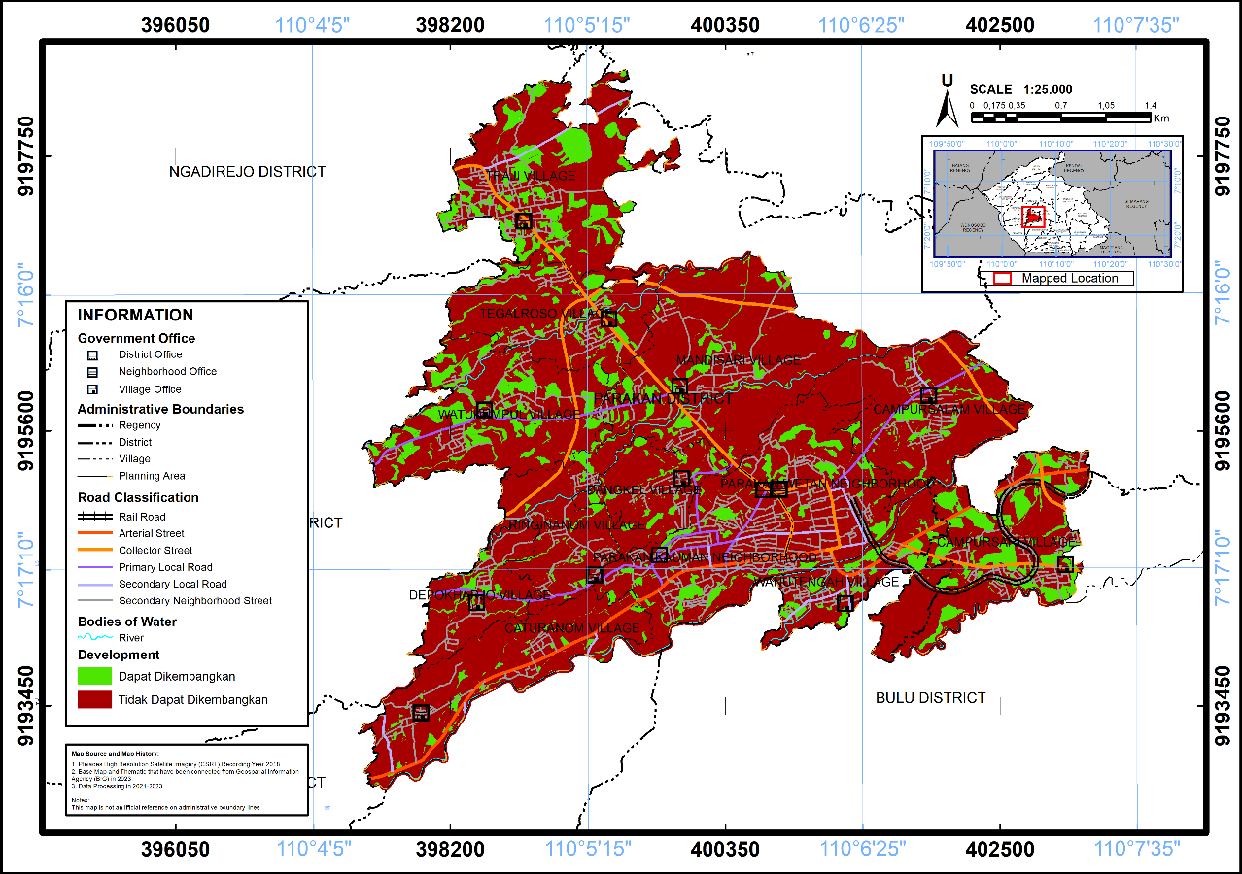

**Figure 3.** Map of Land Availability in Parakan Urban Area

*Source : 2024 Compiler*

# CONCLUSIONS

Based on the results of the analysis of the study of housing needs in the Parakan Urban Area of Temanggung Regency that has been carried out, the projected population in 2043 is estimated to reach 63,718 people with a projected number of families of 15,930. Areas with increasing population growth due to urbanization so that the provision of housing is the main concern of spatial planning. Backlog of housing needs in 2043 there are 2,237 units with land requirements based on the class of the house with details of the number of luxury housing needs in the Parakan Urban Area as many as 373 units with an area of Luxury House (200 $m^{2})$ of 74,555.73 $m^{2}$; Medium House (120 $m^{2})$ of 89,466.88 $m^{2}$ with a total of 746 units; Simple House of 78,283.52 ${ m}^{2}$ with a total of 1,118 units. Overall the area of housing needs with facilities (15%), infrastructure and utilities (30%) amounted to 35.13 ha. In 2043, Parakan Urban Area has 243.97 ha of land that can be developed as housing land, while the housing needs in 2043 are only 35.13 ha, so that the existing land can still meet the housing land needs for the next 20 years.

# REFERENCES

Badan Standardisasi Nasional. (2004). SNI 03-1733-2004 Tata Cara Perencanaan Lingkungan Perumahan di Perkotaan. *Badan Standardisasi Nasional*, 1–58.

Bai, Y., Sun, G., Li, Y., Ma, P., Li, G., & Zhang, Y. (2021). Comprehensively analyzing optical and polarimetric SAR features for land-use/land-cover classification and urban vegetation extraction in highly-dense urban area. *International Journal of Applied Earth Observation and Geoinformation*, *103*(June), 102496. https://doi.org/10.1016/j.jag.2021.102496

Chen, M., Gong, Y., Li, Y., Lu, D., & Zhang, H. (2016). Population distribution and urbanization on both sides of the Hu Huanyong Line: Answering the Premier’s question. *Journal of Geographical Sciences*, *26*, 1593–1610. https://doi.org/10.1007/s11442-016-1346-4

Fahmi;, & Widyawati, R. (2020). Analisis Kebutuhan Pengembangan Perumahan Dan Kawasan Permukiman Kabupaten Pesisir Barat Tahun 2018 – 2037. *Jurnal Profesi Insinyur Universitas Lampung*, *1*(2), 40–53. https://doi.org/10.23960/jpi.v1n2.49

Fasola, D., Purba, A., & Kustiani, I. (2022). Analisis Kebutuhan Pengembangan Perumahan Dan Kawasan Permukiman Kabupaten Tanggamus Tahun 2022 - 2041. *Seminar Nasional Insinyur Profesional (SNIP)*, *2*(2). https://doi.org/10.23960/snip.v2i2.189

Firdianti, S. (2010). *Perkembangan Permukiman Penduduk di Kecamatan Ngemplak Kabupaten Boyolali*. 7–110.

Handiyatmo, D., Sahara, I., & Rangkuti, H. (2010). Pedoman Penghitungan Proyeksi Penduduk dan Angkatan Kerja. In *Badan Pusat Stastistik*.

Herningtyas Astrid Tiara Ega;, Lakat, R. M. S., & Punuh, C. S. (2024). *PENYEDIAAN HUNIAN DI KOTA MANADO*. *11*(2), 1–12.

Kaunang, N. F., Mustofa, U., Astha, D. P., & Hidayat, A. (2024). Analisis Kesesuaian Peruntukan Ruang Kawasan Lindung Kota Balikpapan Terhadap Rencana Detail Tata Ruang (RDTR) Kota Balikpapan. *COMPACT: Spatial Development Journal*, *3*(1), 140–146. https://doi.org/10.35718/compact.v3i1.1147

Li, M., He, B., Guo, R., Li, Y., Chen, Y., & Fan, Y. (2018). Study on population distribution pattern at the county level of China. *Sustainability (Switzerland)*, *10*(10), 1–16. https://doi.org/10.3390/su10103598

Marjorie Tindas, G., A. J. Rumagit, G., & G. Jocom, S. (2023). Analisis Backlog Perumahan di Kota Manado (Housing Backlog Analysis in Manado City). *Journal of Agribusiness and Rural Development (Jurnal Agribisnis Dan Pengembangan Pedesaan)*, *4*(2), 239–246. https://doi.org/10.35791/agrirud.v4i2.45056

Musianto, L. S. (2002). Perbedaan Pendekatan Kuantitatif Dengan Pendekatan Kualitatif Dalam Metode Penelitian. *Jurnal Manajemen Dan Wirausaha*, *4*(2), 123–136. https://doi.org/10.9744/jmk.4.2.pp.123-136

Nasution, A. (2017). Kebijakan Pembentukan Modal Sosial Dan Pengurangan Kemiskinan Di Rumah Tangga Perdesaan Indonesia. *Jurnal Ekonomi Dan Kebijakan Publik*, *7*(2), 171. https://doi.org/10.22212/jekp.v7i2.672

Novitawaty, M. (2017). Kajian Kebijakan Rumah Khusus Sebagai Upaya Pemenuhan Kebutuhan Perumahan. *Jurnal KaLIBRASI*, *12*(1), 41–61. https://ejournal.borobudur.ac.id/index.php/teknik/article/view/475

Peraturan Pemerintah RI No 12. (2021). *Peraturan Pemerintah Republik Indonesia Nomor 12 Tahun 2021 Tentang Perubahan Atas Peraturan Pemerintah Nomor 14 Tahun 2016 Tentang Penyelenggaraan Perumahan Dan Kawasan Permukiman* (Issue 086436).

Rahman, A. (2010). *PROGRAM PASCASARJANA MAGISTER TEKNIK PEMBANGUNAN WILAYAH DAN KOTA*.

Roziqin, A., & Kusumawati, I. (2017). Analisis Pola Permukiman Menggunakan Data Penginderaan Jauh di Pulau Batam. *IRONS: 8th Industrial Research Workshop and National Seminar Politeknik Negeri Bandung*, 52–58. https://jurnal.polban.ac.id/proceeding/article/view/698

Rumondor, V., Lakat, R., & Sembel, A. (2024). *ANALISIS KEBUTUHAN DAN PERMINTAAN RUMAH DI KOTA BITUNG*. *11*(2), 24–34.

Talanipa, R., Putri, T. S., Rustan, F. R., & Yulianti, A. T. (2022). Implementasi Aplikasi EPANET Dalam Evaluasi Pipa Jaringan Distribusi Air Bersih PDAM Kolaka. *INFORMAL: Informatics Journal*, *7*(1), 46. https://doi.org/10.19184/isj.v7i1.30802

Widiawaty, M. A. (2023). Faktor-Faktor Urbanisasi di Indonesia. *Pendidikan Geografi UPI*, *February*, 1–10.

Zhang, C., & Li, X. (2022). Land Use and Land Cover Mapping in the Era of Big Data. *Land*, *11*(10). https://doi.org/10.3390/land11101692

Zhu, Q., Xie, C., & Liu, J. B. (2023). The impact of population agglomeration on ecological resilience: Evidence from China. *Mathematical Biosciences and Engineering*, *20*(9), 15890–15911. https://doi.org/10.3934/mbe.2023708