PHARMACOLOGICAL PROPERTIES OF MEDINILLA SPECIOSA WITH POTENTIAL RELEVANCE TO ORAL HEALTH: A SCOPING REVIEW

Arin Oktaviani Suningdyastiningrum*, Fatika Puteri Rosyi Prabowo**, Agam Ferry Erwana*

* Faculty of Dentistry Universitas Duta Bangsa Surakarta
** Faculty of Health Sciences Universitas Duta Bangsa Surakarta
Correspondence: arin_oktaviani@udb.ac.id

Keywords:
Antibacterial activity; antibiofilm activity; Medinilla speciosa; oral health; oral biology
ABSTRACT

Background: Oral health is sustained under the control of a dynamic balance between oral microorganisms, host immunity, and oral tissue. Loss of this balance leads to microbial dysbiosis and inflammation associated with many oral diseases. Multitarget agents such as herbal medicine are therefore being increasingly explored, as conventional medicine can lead to some side effects. Medinilla speciosa (Parijoto), an endemic Indonesian medicinal plant, has been reported to possess diverse pharmacological activities. However, its relevance to oral health has not been systematically synthesized.
Method: A scoping review was carried out using PubMed, ScienceDirect, Google Scholar, and Semantic Scholar using the search keyword: “Medinilla speciosa” AND (antibacterial OR antioxidant OR anti-inflammatory). The pharmacological activity of Medinilla speciosa was recorded in studies.
Result: A total of 253 papers were found 6 papers were selected after rigorous selection process based on the PRISMA scoping review technique. Those studies shows the antibacterial impact on pathogenic bacteria, antioxidant properties, immunomodulation, anti-inflammation. Additionally, although no research has examined the impact of these extracts on oral tissues or models of oral diseases, their pharmacological properties are intriguing in terms of their local control of bacteria, modulation of inflammation, oxidative stress reduction, and tissue repair.
Conclusion: Current evidence suggests that Medinilla speciosa exhibits multitarget pharmacological activities with potential relevance to oral health. However, oral-specific experimental and clinical studies are needed for the further validation of its application in dentistry and oral medicine.

INTRODUCTION
Oral health is determined by a dynamic equilibrium among oral microflora, host immune system, and local tissue environment of the oral cavity. When this balance is disturbed, it can lead to dysbiosis where the condition of microbial overgrowth and chronic inflammation, as evidenced from a variety of oral diseases. These disturbances play a role in the pathogenesis of different oral diseases, such as infectious-inflammatory lesions, biofilm-induced diseases and loss of integrity of the oral tissues which can effect quality of life at the end. Therefore, considering the mechanical forces and microbial insults that oral tissues are constantly exposed to that can lead to chronic condition, maintaining homeostasis in this niche is a challenging and dynamic aspect of oral care (1-3).
Oral health pathological is a complex conditions since it is the result from multifactorial interaction between lots of biological pathways. Dysbiosis in oral cavity may lead to chronic inflammation that could raise the levels of oxidative stress which can disrupt local physiological repair processes (4-6). Some of therapeutic approaches that include antibacterial, antioxidant and anti-inflammatory effects are currently preferred for the treatment of complex mechanisms leading to poor oral health, rather than those works only on single pathological factors (7).
There were conventional therapy of oral health treatment such as antimicrobial and anti-inflammatory medicines. Although these treatments are effective in managing infection and inflammation, it could cause problems like an imbalance in the mouth's bacteria and increased resistance to medicines (7-10). This is increasing the interest in natural products as alternatives for oral health, especially those that have multi-mechanism facing pathological conditions (11-18). By controlling microorganisms, reducing inflammation and modulate immune response at once it could maintains the oral cavity health (11).
Medinilla speciosa or Parijoto is an endemic plant in Indonesia. Medinilla speciosa known has phenolic and flavonoid as its bioactive substance. Previous researches shows that those bioactive substance on Medinilla speciosa does pharmacological properties such as antibacterial, antioxidant, immunomodulatory and anti-inflammatory (12-19). Those study shows that Medinilla speciosa could potentially bring benefits to oral health.
However, to this date there still a few clear evidence that has been carefully collected about Medinilla speciosa is important for oral health. Moreover, studies that directly search how the pharmacological in this plant affect to oral tissue or models of oral disease nearly can’t be found. It brings a gap in our understanding. So that this review aims to gather and summarize the existing evidence about the pharmacological properties of Medinilla speciosa and its relevance to oral health.

METHODS
Data Search
The data search methods involves the gathering of secondary data, which is not directly observed but rather collected from the finding of previous researches. A scooping review was conducted on database engine such as PubMed, ScienceDirect, Google Scholar and Semantic Scholar. The search strategy was designed to retrieve articles evaluating the pharmacological effects of Medinilla speciosa and its relevance to oral health. The Boolean operator used were “Medinilla speciosa” AND (antibacterial OR antioxidant OR anti-inflammatory). The literature search was completed in December 2025. A PRISMA flow diagram were uses to show how the studies was selected
Inclusion and Exclusion Criteria
The criteria must be fulfilled for this review are the studies must be an original research published within the last five years (2021-2025), full text accessible articles, and focus of the research are Medinilla speciosa and its pharmacological effects. Besides, the articles must written in English. Studies that were article type other than original research, only contained abstracts, and did not concentrate on Medinilla speciosa and its pharmacological effects are excluded. This selected literature included in vitro and also in vivo studies.

RESULTS
Identified Studies
Researchers found articles on PubMed, ScienceDirect, Google Scholar and Semantic Scholar. The result of the search, it was found 1 article on PubMed and ScienceDirect, 241 articles from Google Scholar, and 10 articles from Semantic Scholar. Furthermore, researchers manually analysed and removed 220 duplicate articles, and so that 33 articles were screened to make sure included in inclusion criteria. After the screening, here were 27 articles excluded due some reason belongs to exclusion criteria. Finally 6 total of article could be synthesize in this review. The comprehensive selection techniques are illustrated in Figure 1.
Summary of Identified Studies
Out of the 6 studies included, most of them were in vitro assay whereas on study used an animal model. Most of the studies used extracts from the fruit or leaves of Medinilla speciosa and used alcohol as the method to get the extracts (13, 14, 16-19).
The study included mostly investigate pharmacological aspect, such as antibacterial, antioxidant, anti-inflammation, which were also the main things we were checking in this review. To investigate the antibacterial, most of studies used in vitro methods on agar plate (16, 17, 19). Antioxidant effectivity shown by how Medinilla speciosa could neutralize harmful free radicals. Besides, it also depends on how much phenolic or flavonoid substances they had (14). For the anti-inflammatory effects, the studies evaluate how Medinilla speciosa affect not only immune but also inflammation responses (13, 18).
Although there’s none of the included studies specifically focus investigated oral tissues or oral disease models, the reported of pharmacological activities are mechanistically relevant to oral health. The characteristics and main findings of the included studies are summarized in Table 1.

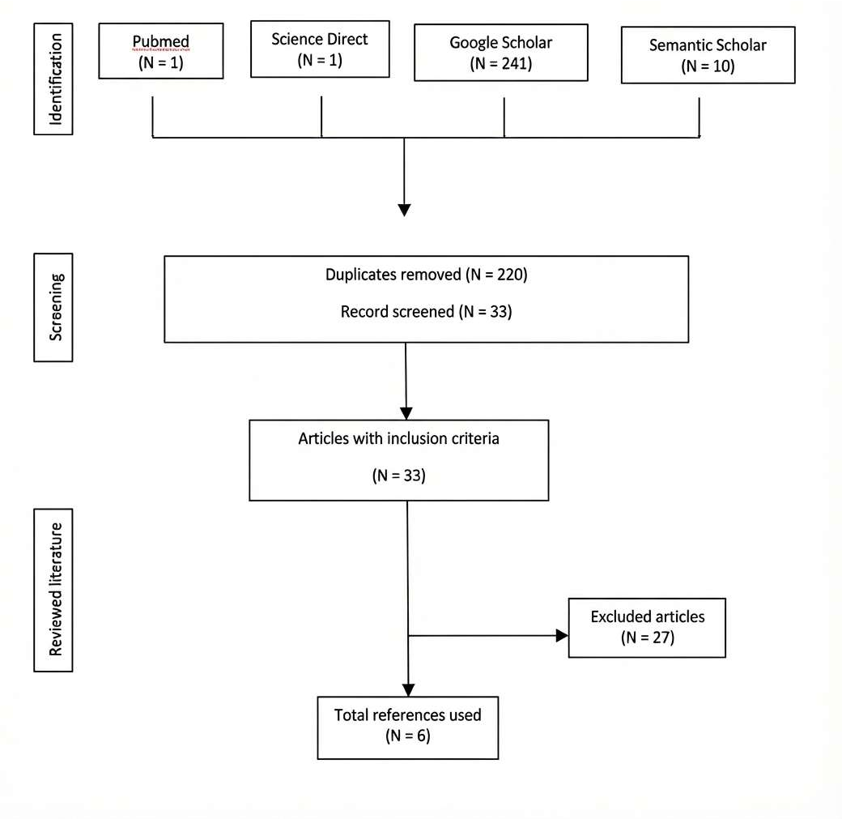

Figure 1. In the diagram, records are shown on PRISMA. Our initial search shows a total of 253 potential articles. Due to duplication, 220 articles were eliminated. Screening by titles, abstract and keyword on full text was conducted and founds 33 articles from this process based on inclusion criteria. Due to exclusion criteria, 27 articles were excluded. For the final, there were 6 articles decided for final synthesis.

Table 1. Pharmacological Properties from Reviewed Article and It’s Relevance to Oral Health

Ref | Pharmacological Activity | Findings of Studies | The Relevance to Oral Health
Milanda et al. (2021)  (16) | Antibacterial | Medinilla speciosa has antibacterial activity on Streptococcus aureus and Streptococcus marcescens | The antibacterial properties potentially control of pathogenic bacteria involved in oral infection and dysbiosis (20)
Farida et al. (2021)  (17) | Antibacterial | Medinilla speciosa has antibacterial activity on Pseudomonas aeruginosa | Antibacterial broad-spectrum potentially against opportunistic gram-negative bacteria (20)
Damayanti et al. (2025)  (14) | Antioxidant | Medinilla speciosa has phenolic and flavonoid as phytochemical substance which has the role as antioxidant | Antioxidant properties potentially protect oral tissue from oxidative stress associated with prolonged inflammation (5)
Winanta wt al. (2025)  (18) | Immunomodulatory | Flavonoid compund on Medinilla speciosa exhibit a correlation with the immunomodulatory activity | Immunomodulation may support host defense and immune balance in oral tissue (3)
Sa’adah et al. (2025)  (19) | Antibacterial | Medinilla speciosa has view phytochemical substance such as saponins, flavonoids, tannins, alkaloids, quinones, and phenols which has capability on antibacterial activity | The antibacterial activity potentially helps prevent oral cavity from pathogenic bacteria and dysbiosis (20)
Luhurningtyas et al. (2025)  (13) | Anti-inflammatory | Medinilla speciosa reduced leukocyte as inflammatory represent cell on initial wound healing process | Anti-inflammatory activity support on oral wound healing tissue (21, 22)

DISCUSSION
Based the results from 6 original studies, the research indicates that Medinilla Speciosa has multiple pharmacological effect such as antibacterial, antioxidant, anti-inflammatory and immunomodulatory that potentially impact different processes related to the development of oral disease. While none of the studies were conducted directly on oral tissues or models of oral disease, the effects observed are scientifically linked to maintaining equilibrium in the oral cavity.
Antibacterial Activity and Implications for Oral Microbial Control
Medinilla speciosa extracts have been found to be effective in fighting harmful bacteria. Milanda et al. used ethanolic fruit extracts assay to inhibit the growth of Staphylococcus aureus and Serratia marcescens, which showed antibacterial activity against both Gram-positive and Gram-negative organism (16). Another research conducted by Farida et al. showed that Medinilla speciosa extracts proven killing Pseudomonas aria. It shows that Medinilla speciosa has antibacterial ability (17). Sa’adah et al. also prove that Medinilla speciosa has view phytochemical substance such as saponins, flavonoids, tannins, alkaloids, quinones, and phenols which has capability on antibacterial activity (19).
Dysbiosis and excessive bacterial growth are central contributors to the development of oral cavity disease such as dental caries and periodontal disease (23, 24). Even though the selected studies conduct the antibacterial activity not specific on oral pathogens, it shows that Medinilla speciosa has pharmacological properties
which potentially relevant for suppressing microbial growth in the oral environment. Nevertheless, further studies employing oral bacterial isolates are required to confirm this applicability.
Antioxidant Activity and Protection Against Oxidative Stress
Excessive level of oxidative stress plays role in damaging oral tissues and causing prolong inflammation. A study held by Damayanti et al. revealed that ethanolic extract from Medinilla speciosa has high levels of total phenolic and flavonoid substances which aid in the effective inhibition of harmful free radicals (14).
Excessive levels of reactive oxygen species in oral tissues can lead to chronic wound healing conditions. Antioxidant could support the making of balance reactive oxygen species environments (5, 20)
Immunomodulatory Effects and Host Response Regulation
The research conducted by Winanta et al. found that Medinilla speciosa helped macrophages work better at eating harmful things and also made lymphocytes multiply more, showing that it can affect both the body's first-line and long-term immune defenses (18). The highlight of this study, it is assessed immune cell function rather than direct suppression of inflammatory mediators.
In oral health, balanced immune responses are crucial for controlling microbial challenges while preventing excessive tissue destruction. Dysregulated immune activation or dysbiosis is a hallmark chronic or inflammatory oral disease condition (3, 4).
Anti-inflammatory and Tissue Repair Potential
Oral wound tissues often caused by physical injury, surgeries, and inflammation and lead to mastication or phonation dysfunction. Therefore, it's important for wounds to heal properly. A study conducted by Luhurningtyas et al. showed that applying a gel made from Medinilla speciosa directly to wounds helped them close faster and made the tissue repair better in a rat model where wounds were made intentionally (13). This wound-healing activity was associated with changes in leukocyte responses, suggesting involvement of inflammatory and reparative processes.
Even though this wound model is not designed for mouth, it shows that the role of Medinilla speciosa on anti-inflammatory capability in tissue repair remains crucial to oral wound healing. This is due to the special healing properties of the oral mucosa, which are more susceptible to injury. These findings suggest Medinilla speciosa may be useful in treating oral wound, but further studies with specific-mouth models are needed (21, 22).
Overall Interpretation
According to the results of this review, Medinilla speciosa has several pharmacological properties that potentially impact oral health (Figure 2). However, due to the limitations of this study, the results indicate that additional studies of Medinilla speciosa effects on the oral cavity are required to be developed.

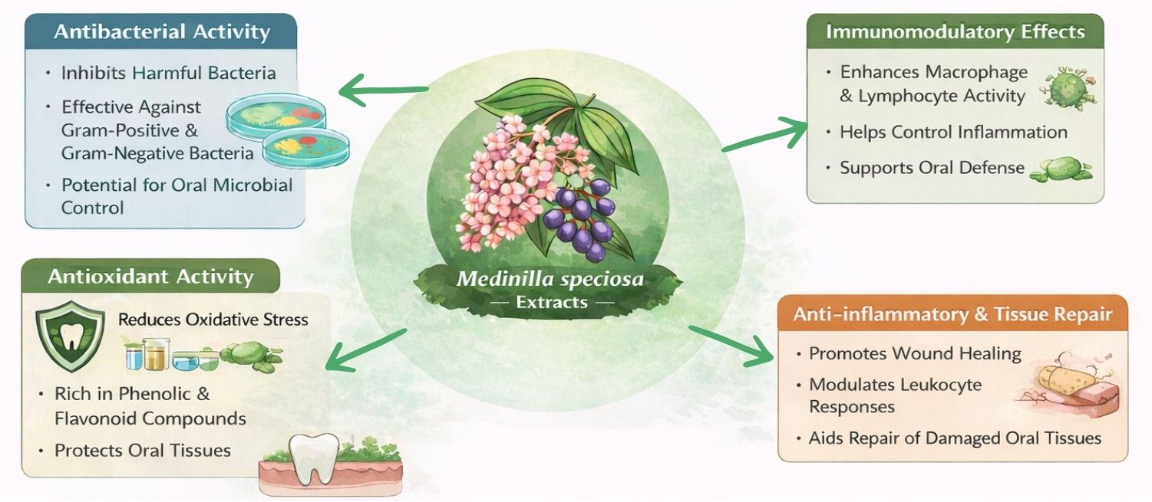
Figure 2. Medinilla speciosa extracts exhibit antibacterial, antioxidant, immunomodulatory, and anti-inflammatory–related activities based on experimental evidence. These multitarget effects may contribute and relevant to oral health.

CONCLUSION
The current experimental evidence presented in this scoping review indicates that Medinilla speciosa has various pharmacological effects, such as antibacterial, antioxidant, immunomodulatory, and anti-inflammatory. The activities are mechanistically significant and relevant to several key processes in oral health maintenance, including microbial control, modulation of inflammatory and immune responses, reduction of overall oxidative stress, and facilitation of tissue repair.
USE OF AI TOOLS DECLARATION
During the process making this article, the author used Quillbot for grammar checking. However, the authors reviewed and edited the content as needed after, and took full responsibility for the content of the publication. Authors also used ChatGPT to generate a non-plagiarized figure (Figure 2). After using this tool, the authors reviewed and edited the content as needed with Canva photo editor.
AUTHOR CONTRIBUTIONS
AOS contribute to constructed the study design, supervised and responsible for all process until the submission of this articles. FPRP and AFE contribute to the data analysis, review, and design of the illustration for this article.
AKNOWLEDGEMENT
The authors acknowledge LPPM Universitas Duta Bangsa Surakarta.
CONFLICT OF INTEREST
The authors have no conflict to declare.
REFERENCES
1. Block C, Konig HH, Hajek A. Oral health and quality of life: findings from the Survey of Health, Ageing and Retirement in Europe. BMC Oral Health. 2022;22(1):606.
https://pmc.ncbi.nlm.nih.gov/articles/PMC9753255/
2. Caselli E, Fabbri C, D'Accolti M, Soffritti I, Bassi C, Mazzacane S, et al. Defining the oral microbiome by whole-genome sequencing and resistome analysis: the complexity of the healthy picture. BMC Microbiol. 2020;20(1):120.
https://pubmed.ncbi.nlm.nih.gov/32423437/
3. Gaffen SL, Moutsopoulos NM. Regulation of host-microbe interactions at oral mucosal barriers by type 17 immunity. Sci Immunol. 2020;5(43).
https://pubmed.ncbi.nlm.nih.gov/31901072/
4. Kanzaki H, Wada S, Narimiya T, Yamaguchi Y, Katsumata Y, Itohiya K, et al. Pathways that Regulate ROS Scavenging Enzymes, and Their Role in Defense Against Tissue Destruction in Periodontitis. Front Physiol. 2017;8:351.
https://pubmed.ncbi.nlm.nih.gov/28611683/
5. Liu W, Guo D. Oxidative stress in periodontitis and the application of antioxidants in treatment: a narrative review. Front Physiol. 2025;16:1485367.
https://pubmed.ncbi.nlm.nih.gov/40488141/
6. Hunt M, Torres M, Bachar-Wikstrom E, Wikstrom JD. Cellular and molecular roles of reactive oxygen species in wound healing. Commun Biol. 2024;7(1):1534.
https://pubmed.ncbi.nlm.nih.gov/39562800/
7. Monika P, Chandraprabha MN, Rangarajan A, Waiker PV, Chidambara Murthy KN. Challenges in Healing Wound: Role of Complementary and Alternative Medicine. Front Nutr. 2021;8:791899.
https://pubmed.ncbi.nlm.nih.gov/35127787/
8. Oliveira A, Simões S, Ascenso A, Reis CP. Therapeutic advances in wound healing. J Dermatolog Treat. 2022;33(1):2-22.
https://pubmed.ncbi.nlm.nih.gov/32056472/
9. Kolimi P, Narala S, Nyavanandi D, Youssef AAA, Dudhipala N. Innovative Treatment Strategies to Accelerate Wound Healing: Trajectory and Recent Advancements. Cells. 2022;11(15).
https://www.mdpi.com/2073-4409/11/15/2439
10. Hayashi M, Morimoto Y, Iida T, Tanaka Y, Sugiyama S. Risk of Delayed Healing of Tooth Extraction Wounds and Osteonecrosis of the Jaw among Patients Treated with Potential Immunosuppressive Drugs: A Retrospective Cohort Study. Tohoku J Exp Med. 2018;246(4):257-64.
https://pubmed.ncbi.nlm.nih.gov/30568073/
11. Anwar MA, Sayed GA, Hal DM, Hafeez MSAE, Shatat A-AS, Salman A, et al. Herbal remedies for oral and dental health: a comprehensive review of their multifaceted mechanisms including antimicrobial, anti-inflammatory, and antioxidant pathways. Inflammopharmacology. 2025;33(3):1085-160.
https://pubmed.ncbi.nlm.nih.gov/39907951/
12. Vifta RL, Sunnah I, Chanifah N, Advistasari Y. PURIFIKASI BUAH PARIJOTO (Medinilla speciosa Blume) DAN UJI BIOAKTIVITASNYA SEBAGAI ALTERNATIF PENGOBATAN DIABETES MELLITUS. Media Informasi Penelitian Kabupaten Semarang. 2019;2:185-99.
https://sinov.semarangkab.go.id/index.php/sinov/article/view/92
13. Luhurningtyas F, Vifta RL, Musyarofah M. The Effect of Administration of Parijoto Fruit Extract Gel (Medinilla speciosa) on Incision Wound Healing and Total Leukocyte Count in Male Wistar White Rats. Research Journal of Pharmacy and Technology. 2025:2010-6.
https://rjptonline.org/AbstractView.aspx?PID=2025-18-5-10
14. Damayanti PN, Luhurningtyas FP, Indrayati LL. Penetapan Kadar Fenolik dan Flavonoid Total Ekstrak Etanol Buah Parijoto (Medinilla speciosa Blume) dengan Metode Spektrofotometri UV-Vis. Jurnal Farmasi (Journal of Pharmacy). 2023.
https://www.researchgate.net/publication/373912526_Penetapan_Kadar_Fenolik_dan_Flavonoid_Total_Ekstrak_Etanol_Buah_Parijoto_Medinilla_speciosa_Blume_dengan_Metode_Spektrofotometri_UV-Vis
15. Toni.S R, Apriana M, Huda M, Kamal M, Allahuddin, Septiani R, et al. ARTIKEL REVIEW: STUDI FITOKIMIA DAN FARMAKOLOGI PARIJOTO (Medinilla magnifica). Jurnal Buana Farma. 2022;2:36-46.
https://pdfs.semanticscholar.org/d490/777f480aa10920f4c63670883e88ac6f5a92.pdf
16. Milanda T, Lestari K, Tarina N. Antibacterial Activity of Parijoto (Medinilla speciosa Blume) Fruit Against Serratia marcescens and Staphylococcus aureus. Indonesian Journal of Pharmaceutical Science and Technology. 2021;8:76.
https://jurnal.unpad.ac.id/ijpst/article/view/32166
17. Farida R, Vifta R, Erwiyani A. Uji Aktivitas Antibakteri Ekstrak Buah Parijoto (Medinilla Spesiosa B.) Dengan Perbandingan Pelarut Etanol 70% Dan Etanol 96% Terhadap Bakteri Pseudomonas Aeruginosa. Indonesian Journal of Pharmacy and Natural Product. 2021;4.
https://share.google/GuG0EOX8ynQ7ssD7V
18. Winanta A, Bagir H, Febriansah R, Nugraha AT. The immunomodulatory activity of parijoto fruit (Medinilla speciosa) fraction against phagocytosis macrophages and lymphocyte proliferation. J Adv Pharm Technol Res. 2025;16(1):6-11.
https://pubmed.ncbi.nlm.nih.gov/40177515/
19. Sa'adah A, Sari F, Sukoharjanti B, Darmawati S. The Effectiveness of Antibiofilm Synergy of Parijoto Leaf Extract (Medinilla speciosa) and Gentamicin on Methicillin-Resistant Staphylococcus aureus (MRSA) from Diabetic Ulcers. Media Kesehatan Politeknik Kesehatan Makassar. 2025;20:330-8.
https://ojs3.poltekkes-mks.ac.id/index.php/medkes/article/view/1715
20. Mira A, Simon-Soro A, Curtis MA. Role of microbial communities in the pathogenesis of periodontal diseases and caries. J Clin Periodontol. 2017;44 Suppl 18:S23-s38.
https://pubmed.ncbi.nlm.nih.gov/28266108/
21. Waasdorp M, Krom BP, Bikker FJ, van Zuijlen PPM, Niessen FB, Gibbs S. The Bigger Picture: Why Oral Mucosa Heals Better Than Skin. Biomolecules. 2021;11(8).
https://pubmed.ncbi.nlm.nih.gov/34439831/
22. Toma AI, Fuller JM, Willett NJ, Goudy SL. Oral wound healing models and emerging regenerative therapies. Transl Res. 2021;236:17-34.
https://pubmed.ncbi.nlm.nih.gov/34161876/
23. Kilian M, Chapple IL, Hannig M, Marsh PD, Meuric V, Pedersen AM, et al. The oral microbiome - an update for oral healthcare professionals. Br Dent J. 2016;221(10):657-66.
https://pubmed.ncbi.nlm.nih.gov/27857087/
24. Jakubovics NS, Goodman SD, Mashburn-Warren L, Stafford GP, Cieplik F. The dental plaque biofilm matrix. Periodontol 2000. 2021;86(1):32-56.
https://pubmed.ncbi.nlm.nih.gov/33690911/

