**Figures**

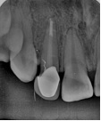

**Figure 1.** Radiograph features of fiber post

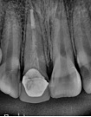

**Figure 2.** Radiograph features with FRC post