# LAMPIRAN

## Gambar 1

Kerangka Penelitian

**Variabel Independen**

**Ukuran Komite Audit (X1)**

**Jumlah Pertemuan Komite Audit (X2)**

**Variabel Dependen**

**Komite Audit Independen (X3)**

**Manajemen Laba (Y)**

**Keahlian Komite Audit (X4)**

**Ukuran Kantor Akuntan Publik (X5)**

## Tabel 1

## Statistik Deskriptif

|  |  |  |  |  |  |
| --- | --- | --- | --- | --- | --- |
|  | | | | | |
|  | N | Minimum | Maximum | Mean | Std. Deviation |
| Ukuran Komite Audit (X1) | 48 | 2 | 5 | 3,21 | ,544 |
| Jumlah Pertemuan Komite Audit (X2) | 48 | 3 | 44 | 8,77 | 8,784 |
| Komite Audit Independen (X3) | 48 | ,33 | 1,00 | ,9581 | ,16390 |
| Keahlian Komite Audit (X4) | 48 | ,20 | 1,00 | ,6071 | ,25194 |
| Ukuran Kantor Akuntan Publik (X5) | 48 | 0 | 1 | ,50 | ,505 |
| Manajemen Laba (Y) | 48 | ,9212 | 1,2012 | 1,022199 | ,0586821 |
| Valid N (listwise) | 48 |  |  |  |  |

Sumber: *Output IBM SPSS Statistics 25*

## Tabel 2

**Uji Asumsi Klasik**

Hasil Uji Normalitas : Nilai *Kolmogrov-Smirnov Test*

|  |  |  |
| --- | --- | --- |
| **One-Sample Kolmogorov-Smirnov Test** | | |
|  | | Unstandardized Residual |
| N | | 48 |
| Normal Parametersa,b | Mean | ,0000000 |
| Std. Deviation | ,05438208 |
| Most Extreme Differences | Absolute | ,105 |
| Positive | ,105 |
| Negative | -,073 |
| Test Statistic | | ,105 |
| Asymp. Sig. (2-tailed) | | ,200 |
| a. Test distribution is Normal. | | |
| b. Calculated from data. | | |

Sumber: *Output IBM SPSS Statistics 25*

Hasil Uji Multikolinieritas

|  |  |  |  |  |
| --- | --- | --- | --- | --- |
| **Coefficientsa** | | | | |
| Model | | Collinearity Statistics | |
| Tolerance | VIF |
| 1 | (Constant) |  |  |
| Ukuran Komite Audit | ,462 | 2,165 |
| Jumlah Pertemuan Komite Audit | ,669 | 1,495 |
| Komite Audit Independen | ,716 | 1,397 |
| Keahlian Komite Audit | ,467 | 2,140 |
| Ukuran Kantor Akuntan Publik | ,650 | 1,539 |
| a. Dependent Variable: Manajemen Laba | | | | |

Sumber: *Output IBM SPSS Statistics 25*

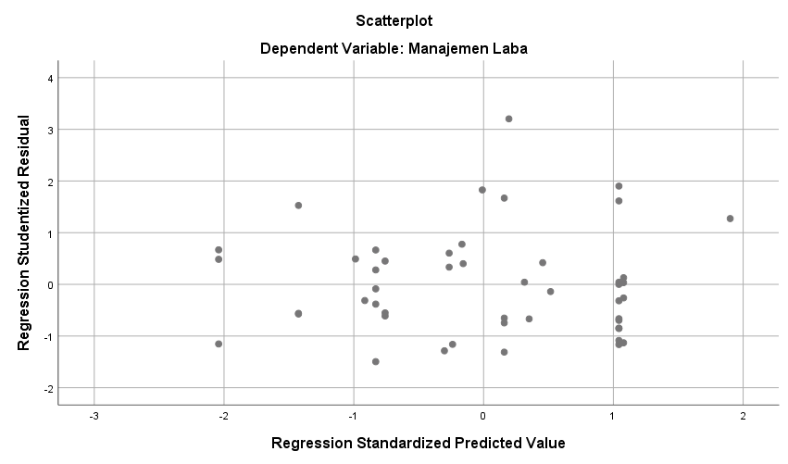

Gambar 4.3 Hasil Uji Heteroskedastisitas : Grafik *Scatterplot*

Sumber: *Output IBM SPSS Statistics 25*

Hasil Uji Autokorelasi

|  |  |  |  |  |  |
| --- | --- | --- | --- | --- | --- |
| **Model Summaryb** | | | | | |
| Model | R | R Square | Adjusted R Square | Std. Error of the Estimate | Durbin-Watson |
| 1 | ,376a | ,141 | ,039 | ,0575281 | 2,525 |
| a. Predictors: (Constant), Ukuran Kantor Akuntan Publik, Komite Audit Independen, Ukuran Komite Audit, Jumlah Pertemuan Komite Audit, Keahlian komite audit | | | | | |
| b. Dependent Variable: Manajemen Laba | | | | | |

Sumber: *Output IBM SPSS Statistics 25*

## Tabel 3

Hasil Uji Statistik t

|  |  |  |  |  |  |  |  |
| --- | --- | --- | --- | --- | --- | --- | --- |
| **Coefficientsa** | | | | | | | |
| Model | | Unstandardized Coefficients | | Standardized Coefficients | t | Sig. |
| B | Std. Error | Beta |
| 1 | (Constant) | 1,000 | ,086 |  | 11,579 | ,000 |
| Ukuran Komite Audit (X1) | -,017 | ,023 | -,161 | -,766 | ,448 |
| Jumlah Pertemuan Komite Audit (X2) | ,001 | ,001 | ,119 | ,681 | ,500 |
| Komite Audit Independen (X3) | ,132 | ,061 | ,369 | 2,183 | ,035 |
| Keahlian Komite Audit (X4) | -,057 | ,049 | -,246 | -1,176 | ,246 |
| Ukuran Kantor Akuntan Publik (X5) | -,041 | ,021 | -,356 | -2,005 | ,051 |
| a. Dependent Variable: Manajemen Laba | | | | | | | |

Sumber: *Output IBM SPSS Statistics 22*