STATEMENT OF ORIGINALITY

To:
Editor-in-chief
Indonesian Journal of Community Service (IjoCS)

With this letter I/we declare that:
Title of article: Sikap dan Perilaku Sosial Masyarakat Bengkulu Terhadap Penggunaan Media Sosial Sebagai Diseminasi Informasi, Bimbingan Pribadi-Sosial dan Deradikasisasi
Author : 1. Dr. Zubaedi, M.Ag., M.Pd
2. Prio Utomo, M.Pd

has been approved by the co-author/s to be published in Indonesian Journal of Community Service (IjoSC), does not contain plagiarism as a whole or in parts, and is not currently being submitted/ processed in other journals.

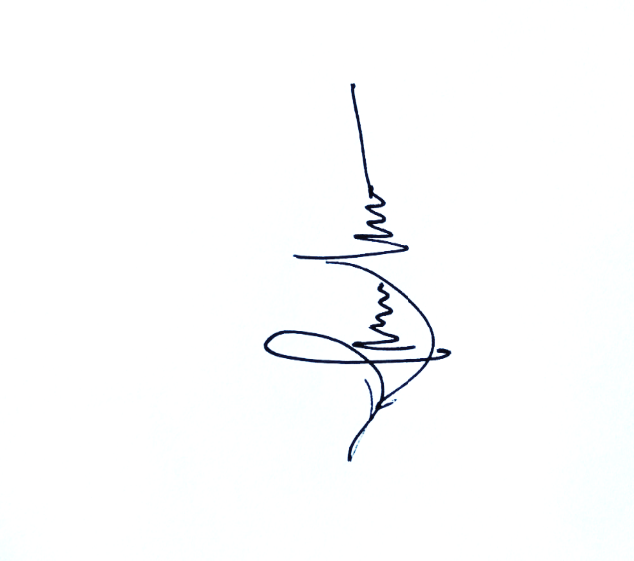
Bengkulu, September, 23, 2021
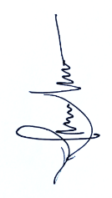
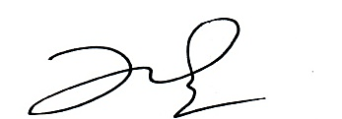
Authors Signatures
1st Author (Dr. Zubaedi, M.Ag., M.Pd
2nd Author (Prio Utomo, M.Pd)

