STATEMENT OF ORIGINALITY

To:
Editor-in-chief
IJIBE (International Journal of Islamic Business Ethics)

With this letter I declare that:
Title of article: The Potential Industry of Islamic Tourism in ASEAN Countries
Author : Rininta Nurrachmi

has been approved by the co-author/s to be published in IJIBE (International Journal of Islamic Business Ethics) does not contain plagiarism as a whole or in parts, and is not currently being submitted/ processed in other journals.

Gombak (Kuala Lumpur), September, 23rd, 2019
Authors Signatures
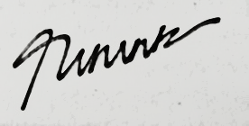

1st Author (Full name with title) Rininta Nurrachmi

