STATEMENT OF ORIGINALITY

To:
Editor-in-chief
EduLite: Journal of English Education, Literature and Culture

With this letter we declare that:
Title of article: CLIL practice in Maritime English course: EFL student perception

Author : 1. Nurmala Elmin Simbolon
2. Sadri

has been approved by the co-author/s to be published in EduLite: Journal of English Education, Literature and Culture, does not contain plagiarism as a whole or in parts, and is not currently being submitted/ processed in other journals.

Pontianak, November, 30, 2019
Authors Signatures
Dr. Nurmala Elmin Simbolon, S.S, M. Ed 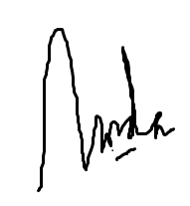
Sadri, S.St. Pi, M.T 