**STATEMENT OF ORIGINALITY**

To:

Editor-in-chief

EduLite: Journal of English Education, Literature and Culture

With this letter I declare that:Title of article: Personal Pronouns *Ité* as Politeness Marker in Manggarai Language and Culture, Indonesia

Authors : Ignas Loy Semana, Sebastianus Menggo

has been approved to be published in EduLite: Journal of English Education, Literature and Culture, does not contain plagiarism as a whole or in parts, and is not currently being submitted/ processed in other journals.

Ruteng, April, 13, 2022

**Authors Signatures**

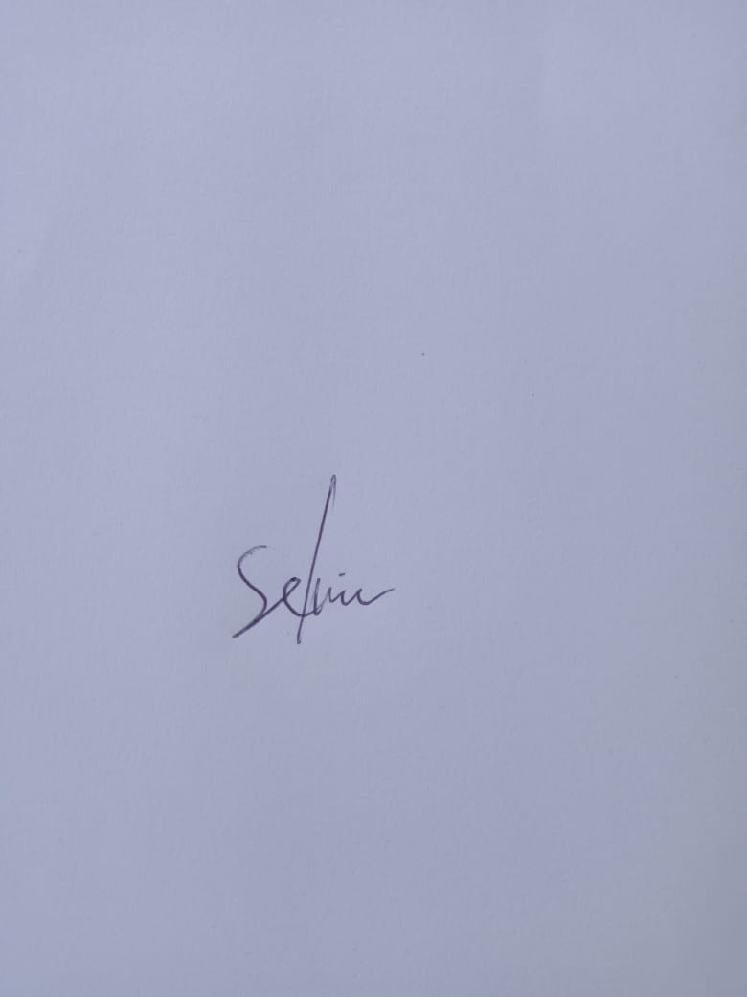

Dr. Sebastianus Menggo, M.Pd .....................................

Ignas Loy Semana, M.Hum .....................................