STATEMENT OF ORIGINALITY

To:
Editor-in-chief
EduLite: Journal of English Education, Literature and Culture

With this letter I/we declare that:
Title of article: The Use of Project Based Learning in Teaching Speaking Skill to Young Learners
Author : 1. Wulan Pangesti
2. Elok Widiyati, M.Pd.

has been approved by the co-author/s to be published in EduLite: Journal of English Education, Literature and Culture, does not contain plagiarism as a whole or in parts, and is not currently being submitted/ processed in other journals.

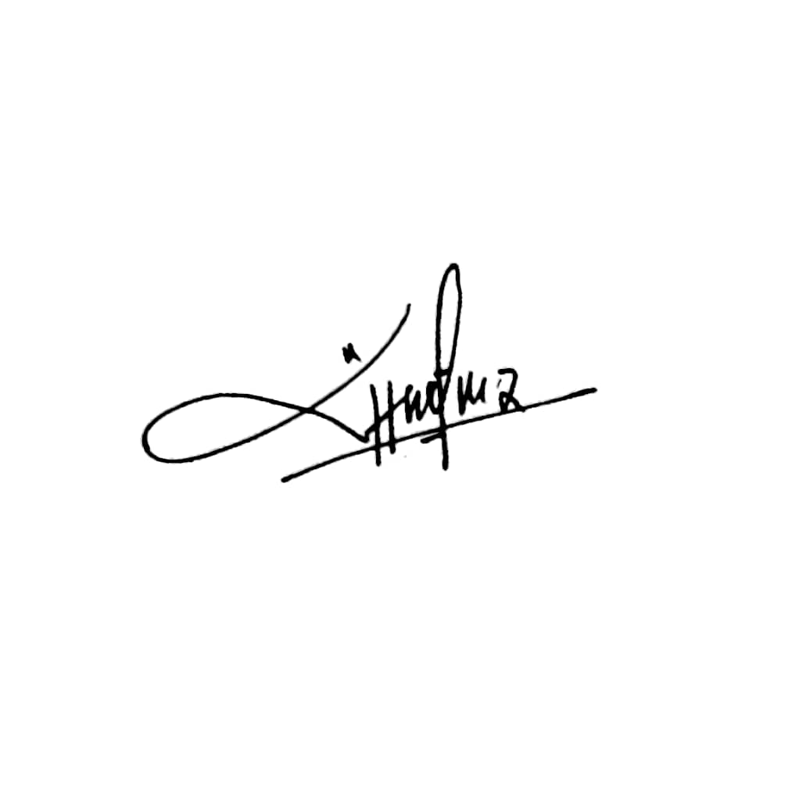
Semarang, December 20th 2021
Authors Signatures

1st Wulan Pangesti .....................................
2nd Elok Widiyati, M.Pd. ......................................

