FIGURE

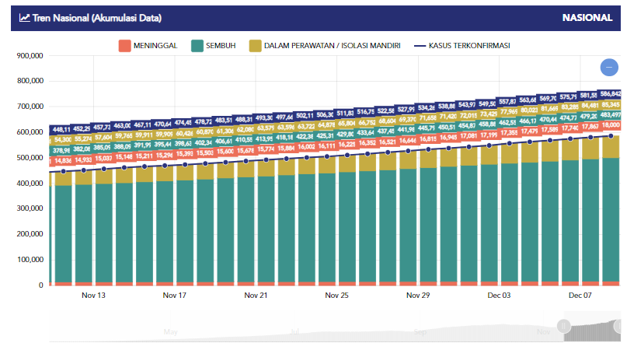
Figure 1. National Trends (Data Accumulation)

